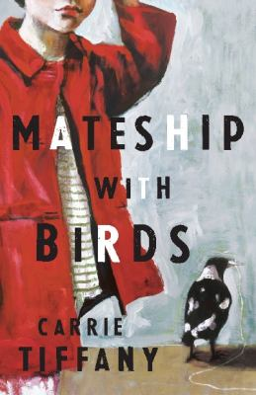
Mateship with Birds by Carrie Tiffany

Synopsis
Set in the early 1950s near Cohuna, a small place north of Melbourne on the Murray Valley Highway, this novel tells a love story of sorts, as Harry and Betty forge a tentative partnership. Dairy farmer Harry lives next door to single mother Betty Reynolds who is in her mid-forties, and her children Little Hazel and Michael. Both feel an attraction to each other, and this novel traces the delicate dance of their mateship, over a year during which Harry watches a flock of kookaburras through his binoculars, and Betty often has her binoculars trained on him.
This novel is also about how we see (or don’t see) the landscape around us. Like Tiffany’s first novel, it’s about the impact we have on the land sometimes without even knowing. Throughout this narrative Harry’s observations of nature infuse his understanding of himself and of others. Betty in contrast has to learn to really look at the world around her, or at least to try and see it through Harry’s eyes. It traces the relationships between birds and animals and people; how we live alone in the face of nature’s threats, but also as part of a community whether it be with family or neighbours. It’s about the sometimes silent communications we have with each other; Harry and Betty speak little of their feelings.
Mateship with birds is a spare and delicately inscribed novel which is a eulogy to landscape and nature, to innocence and experience, to the mysterious powers of love and desire, to how a family might construct itself, and most of all to the lonely nature of our shared existence whether we be man, woman or beast.

Discussion questions
- This novel is a tribute to the powerful natural processes which we all tend to forget when we are confronted with food which is processed and with goods which are manufactured. Discuss.
- What does the novel say about human influences on the land?
- What did you think of Harry’s very idiosyncratic sex education style? Is such personal reminiscence likely to inform or offer guidance to a young boy like Michael?
- Betty’s charges in the nursing home are suffering the sad decline of old age. Their desires are still as strong, but their impaired faculties make them frustrated, querulous and often pathetic. Discuss the treatment of the elderly in relation to Betty’s warm-hearted care for these old men.
- How important is the time period in which this novel is set? For example, would Harry and Betty have had this sort of tentative courtship today? Would Michael have needed Harry’s instruction?
- Bird watching and recognition (pp 184-5) is an art which is celebrated in this novel, as well. Did the novel awaken your interest in really observing the natural world around you, as the author intended it to?
- Were you surprised by, or did you anticipate the ending? What is the major theme or idea behind this novel?
Synopsis/Discussion questions from https://www.panmacmillan.com.au/9781742610764/

