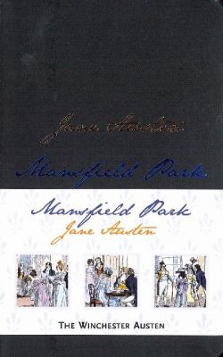
Mansfield Park by Jane Austen

Synopsis
At the novel’s center is Fanny Price, the classic “poor cousin,” brought as a child to Mansfield Park by the rich Sir Thomas Bertram and his wife as an act of charity. Over time, Fanny comes to demonstrate forcibly those virtues Austen most admired: modesty, firm principles, and a loving heart.
As Fanny watches her cousins Maria and Julia cast aside their scruples in dangerous flirtations (and worse), and as she herself resolutely resists the advantages of marriage to the fascinating but morally unsteady Henry Crawford, her seeming austerity grows in appeal and makes clear to us why she was Austen’s own favorite among her heroines.

Discussion questions
- Describe the social positions of the three Ward sisters Lady Bertram, Mrs. Norris, and Mrs. Price. How did they arrive at such different circumstances and how have their circumstances presumably affected their personalities? How do the sisters treat each other and how much of this is the result of their respective status?
- As soon as Sir Thomas decides to accept responsibility for one of Mrs. Price’s children, Fanny is put into an unusual position. Sir Bertram says, although she is to live with them, ‘she is not a Miss Bertram . . . their rank, fortune, rights and expectations will always be different.’ Describe the family’s feelings for Fanny as the novel develops. How does the treatment of Fanny by Mrs. Norris and the Bertram sisters distinguish her from the rest of the children?
- Fanny Price inspires strong reactions in readers; she is cast by some as a dreary killjoy, and by others as an endearing, admirable heroine. Is this dichotomy Austen’s intention? Discuss the ways in which Fanny embodies both sides of this polarized debate. What is your opinion of her in relation to other well-known female protagonists of the day?
- Mansfield Park was divided into three volumes, published separately. Why do you think Austen chose this structure, and how does it affect your reading of the book? Think about other writing that employs this structure to inform your response.
- From the moment the idea is suggested, Edmund is against the staging of a play. Why is the play seen as inappropriate by both Edmund and Fanny? Why, once it is decided upon, does Edmund accept a part in the play, even though he would appear a hypocrite? How much of this license was taken because of the absence of Sir Thomas and how much was simply the influence of Tom? What is the significance of their choice of plays, Lover’s Vows?
- Describe the similarities and differences between the courtship of Edmund and Mary and that of Fanny and Henry. What are the stumbling blocks in these two courtships that cause them to fail? To what extent were the trials of these courtships responsible for Edmund’s change of heart toward Fanny?

Synopsis/Discussion questions from https://www.penguinrandomhouse.com/books/6397/mansfield-park-by-jane-austen/

