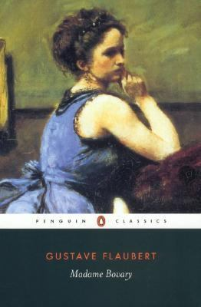
Madame Bovary by Gustave Flaubert

Synopsis
Emma Bovary is the original desperate housewife. Beautiful but bored, she spends lavishly on clothes and on her home and embarks on two disappointing affairs in an effort to make her life everything she believes it should be. Soon heartbroken and crippled by debts, she takes drastic action, with tragic consequences for her husband and daughter.
In this landmark new translation of Gustave Flaubert’s masterwork, award-winning writer and translator Lydia Davis honors the nuances and particulars of Flaubert’s legendary prose style, giving new life in English to the book that redefined the novel as an art form.

Discussion questions
- Reading fiction can be a dangerous thing. Discuss these dangers as exemplified in Madame Bovary.
- Women occupy a large presence in the novel. How is their limited social status examined by Flaubert? Do they possess any power to forge their own destinies?
- Some features of Flaubert’s style have been explored in the translator’s introduction and above. Discuss these features and others-imagery, diction, metaphor, etc.-which you noticed in your reading. How do they provide aesthetic enjoyment?
- One of the most famous set pieces in the novel is the seduction scene during the agriculture fair (part II, chapter 8). Discuss the reasons for its success, especially the author’s use of dialogue.
- Perhaps the most famous line in the entire novel occurs when the narrator likens human speech to a “cracked kettle” (p. 167). The inadequacies of language is another theme that runs throughout the novel. How does this contribute to the work as a whole?
- Charles Bovary is certainly guilty of being a bore and a dupe but does he elicit your sympathy? Is he less worthy of satire than other characters in the novel?
- Emma is certainly guilty of capriciousness, avarice, and licentiousness. Is she, in these faults, any different from the other characters in the novel? Does she rise to the level of tragic heroine?
- Part of the Western literary tradition has portrayed capriciousness, avarice, and licentiousness as stereotypically feminine faults. Does Flaubert challenge these stereotypes in any way in his portrayal of Emma?
- Emma has been whimsically referred to as the ”original desperate housewife.” A gulf of time and social change separates Emma’s world and twenty-first-century America but are their similarities in Emma’s fate and the fate of contemporary married women?
- Is Emma’s tragic demise the result of her circumstances, her own failures, or something else?
Discussion questions from https://www.penguinrandomhouse.com/books/302224/madame-bovary-by-gustave-flaubert/9780143106494/readers-guide/

