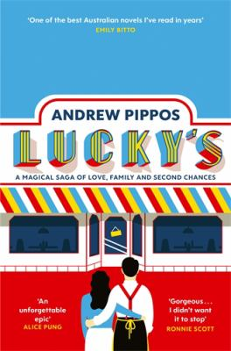
Lucky’s by Andrew Pippos

Synopsis
Lucky's is a story of family.
A story about migration.
It is also about a man called Lucky.
His restaurant chain.
A fire that changed everything.
A New Yorker article which might save a career.
The mystery of a missing father.
An impostor who got the girl.
An unthinkable tragedy.
A roll of the dice.
And a story of love - lost, sought and won again (at last).

Discussion questions
- From the very first page we are told that Lucky wants to ‘fix his own story—to be specific, how it ended’. Do you think Lucky is successful in ‘fixing’ how his story ends? Why, or why not?
- What is the role of lying in Lucky’s, and how does it vary from character to character? What good would the truth do, after all this time?
- How are certain characters in the novel (Achilles, Lucky, and Emily) transformed by migration, and how in turn do they affect their new world?
- The novel places more emphasis on the consequences of violence rather than using violence as a dramatic endpoint. How do the characters confront or contextualise the violent events in their lives?
- Peter Popescu describes Lucky as ‘Don Quixote’ (page 55)—is this an apt description? How would you describe Lucky? What drives him? Do you like him?
- The novel is told from various perspectives—predominantly Emily and Lucky’s. Do you think the novel could be told as effectively from only one point of view? Why, or why not?
- A few chapters before the end of the novel we are told that Emily’s New Yorker article ‘would never be published, nor filed nor finished’ (page 313). Why do you think Pippos chose this point in the novel to reveal this? What affect did this have on your reading of the rest of the novel, and the novel as a whole?
- Lucky’s is a sprawling story that spans several decades. Pippos dramatises certain events in the lives of his characters, and he summarises or refers to other significant moments, but there are some important things he leaves out altogether. What major events does Pippos leave out of Lucky’s? Why?
- What is the significance of what is about to happen in the final scene of the novel?
Discussion questions from https://www.panmacmillan.com.au/9781760787332/

