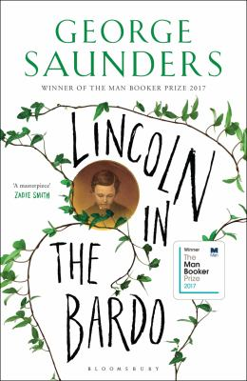
Lincoln in the Bardo by George Saunders

Synopsis
February 1862. The Civil War is less than one year old. The fighting has begun in earnest, and the nation has begun to realize it is in for a long, bloody struggle. Meanwhile, President Lincoln’s beloved eleven-year-old son, Willie, lies upstairs in the White House, gravely ill. In a matter of days, despite predictions of a recovery, Willie dies and is laid to rest in a Georgetown cemetery. “My poor boy, he was too good for this earth,” the president says at the time. “God has called him home.” Newspapers report that a grief-stricken Lincoln returns, alone, to the crypt several times to hold his boy’s body.
From that seed of historical truth, George Saunders spins an unforgettable story of familial love and loss that breaks free of its realistic, historical framework into a supernatural realm both hilarious and terrifying. Willie Lincoln finds himself in a strange purgatory where ghosts mingle, gripe, commiserate, quarrel, and enact bizarre acts of penance. Within this transitional state—called, in the Tibetan tradition, the bardo—a monumental struggle erupts over young Willie’s soul.

Discussion questions
- The presence of a child in the bardo is rare, but what other things about Willie make him different from the other ghosts?
- Which of the ghosts’ stories resonated with you the most?
- How did the style and form of the book enhance or detract from your experience of the story? What did you think of the author’s decision to include snippets of real, historical sources among the fictional narration?
- In what ways do the social structures of this time period manifest in the bardo? How does Saunders play with and explore historical attitudes towards race and class throughout the novel?
- Roger Bevins says that “all were in sorrow, or had been, or soon would be.” Vollman responds by saying “It was the nature of things” and that we are all “suffering, limited beings.” Do you agree?
- George Saunders has described the question at the core of this book as, “How do we continue to love in a world in which the objects of our love are so conditional?” Did you find this to be true, and do you feel like you came to a deeper understanding of mortality?
- Towards the end, the ghosts unite in an attempt to “enter” Lincoln’s mind and stop him from leaving the graveyard. In doing so, they find themselves transformed from their wretched states, remembering parts of their lives that had been lost to them since entering the bardo. Discuss the significance of this transformation.
- Discuss the final scene, in which Thomas Havens follows Lincoln out of the graveyard on horseback. What do you think this foreshadows?

Synopsis/Discussion questions from https://www.penguinrandomhouse.com/books/231506/lincoln-in-the-bardo-by-george-saunders/9780812985405/readers-guide/

