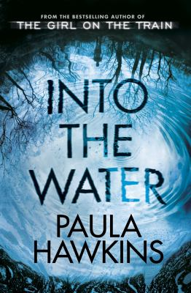
Into the Water by Paula Hawkins

Synopsis
A single mother turns up dead at the bottom of the river that runs through town. Earlier in the summer, a vulnerable teenage girl met the same fate.
They are not the first women lost to these dark waters, but their deaths disturb the river and its history, dredging up secrets long submerged.
Left behind is a lonely fifteen-year-old girl. Parentless and friendless, she now finds herself in the care of her mother's sister, a fearful stranger who has been dragged back to the place she deliberately ran from—a place to which she vowed she'd never return.
Beware a calm surface—you never know what lies beneath

Discussion questions
- Family relationships, particularly the bond between sisters, feature heavily in Into the Water. How do you think Lena is affected by Nel and Jules’s estrangement? How does it influence her friendship with Katie?
- Jules and Nel’s estrangement hinges on a misremembering of an event in their past. Are there any childhood or teenage memories you have that are no longer as clear when you look back now?
- Within the novel there are several inappropriate relationships – for example, Katie and Mark; Sean and Nel; Helen and Patrick. How does the depiction of the relationships between these characters affect your interpretation of their behaviour and actions?
- ‘Beckford is not a suicide spot. Beckford is a place to get rid of troublesome women.’ Discuss the gender dynamic in Into the Water. How much power does each of the women in the novel hold? What are the different types of power they hold?
- Into the Water contains several different voices and perspectives. How did this structure affect your reading of the novel?
- The structure of the novel means that we get tremendous insight into our suspects throughout. Who did you originally think was responsible for Nel’s death? Did your opinion change as the plot developed?
- Was there a particular character you identified with? Was there a particular moment you found moving, surprising, or terrifying?
- Many of the characters in the novel are grieving – some from more recent, raw losses and others from historic ones. How sympathetic were you to these characters? Was there a character you felt more sympathy for than another? Does their grief excuse their behaviour?

Discussion questions from http://paulahawkinsbooks.com/into-the-water/

