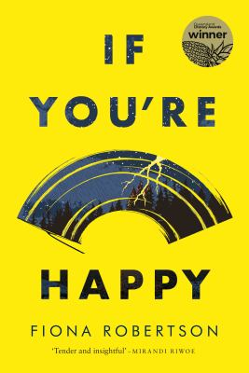
If You’re Happy by Fiona Robertson

Synopsis
The stories in this impressive, thoughtful collection explore the human heart and its desire and capacity for joy.
A divorced woman discovers a growing sinkhole in her yard. A lonely man finds an abandoned toddler. A second wife in a fundamentalist community questions her religion. A young Australian veteran of the Afghanistan conflict is haunted by a memory from his last mission. Fiona Robertson’s stories traverse the globe to reveal people at moments of change or crisis, as they struggle to repair fractures in their lives and search for something close to happiness.

Discussion questions
- What does Shelley yearn for at the end of ‘Tempest’? How does this differ to the way she feels when we meet her?
- How is the concept of humans being neither wholly ‘good’ nor wholly ‘bad’ explored in the story ‘If You’re Happy’?
- How do you predict Dylan will react to his father’s question at the end of ‘Descent’?
- ‘Sweet Bountiful’ contains references to ideal qualities in the Bountiful community, such as being ‘sweet’ and ‘good’. How do you feel about these ideals? How closely do the characters uphold these values?
- How does the way Connor feels about Celia change throughout ‘Shiny Things’? What prompts this change?
- Who do you most relate to in ‘Snowfall’ and why?
- How did your feelings towards Gertie evolve over the course of ‘Aftershock’? Did you expect Tony’s revelation?
- What aspects of ‘Last Game’ (if any) remind you of your own childhood?
- Why do you think Lana agrees to go with Mr Perron in ‘Christmas Party’?
- In ‘Plume’, how is the eruption of Mount Saint Helens reflected in Lori’s life?
- Which story in the collection most affected you and why?
- Many stories in If You’re Happy depict both personal and community crises. How do the characters change when they realise the problem doesn’t just affect them, but those around them as well?

Discussion questions from https://www.uqp.com.au/books/if-youre-happy

