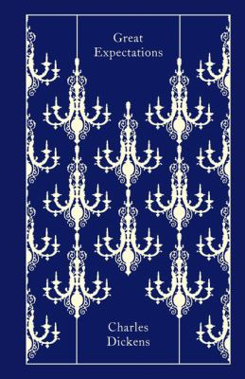
Great Expectations by Charles Dickens

Synopsis
Pip (Philip Pirrip) grows up in the marshlands of Kent, where he lives with his disagreeable sister and her sweet-natured husband, the blacksmith Joe Gargery. A young Pip encounters Abel Magwitch, an escaped convict and is requested to pay visits to Miss Havisham, a woman driven half-mad years earlier by her lover’s departure on their wedding day. Living with Miss Havisham at Satis House is her adopted daughter, Estella. Pip grows increasing ashamed of his humble background and hopes to become a gentleman, in part to win over Estella.
Several years later Pip is informed that an anonymous benefactor has made it possible for him to go to London for an education; Pip believes that the money is from Miss Havisham, who does not dissuade him of the notion. Once in London, Pip is taught to be a gentleman by Matthew Pocket and his son Herbert. The increasingly snobbish Pip is later horrified to discover that his mysterious benefactor is Magwitch. Not only is Magwitch in danger of being arrested, Pip’s social standing is threatened. Before departing England, Pip visits Satis House, where he confronts Miss Havisham for letting him believe she was his patron and professes his love to Estella, who rejects him.
Pip and Magwitch attempt to leave London via a boat, the police and Compeyson arrive. The two convicts end up fighting in the Thames, and only Magwitch surfaces; Compeyson’s body is later recovered. The injured Magwitch is arrested, convicted, and dies awaiting execution. A despondent Pip is arrested because of his debts, but his failing health prevents him from being jailed. Pip later accepts a job offer at the Cairo branch of Herbert’s firm, and he enjoys a simple but content life. After more than 10 years away, he returns to England and visits the place where Satis House once stood. There he encounters Estella, who is now a widow. As they leave, Pip takes her hand, believing that they will not part again.

Discussion questions
- Why do you think it is one of Magwitch's principal conditions that Pip (his nickname) "always bear the name of Pip" in order to receive his financial support?
- If Pip had not received his "Great Expectations" and never left Joe's forge, how do you think his life would have been different? Are the lessons he learns during his physical and emotional journey necessary for him to arrive at the wisdom he evinces as the middle-aged narrator of this tale?
- Why do you think Miss Havisham manipulates and misleads Pip into thinking she is his secret benefactor? What, if anything, does she derive from this action?
- Given Dickens's portrayal of Estella, what do you think attracts Pip to her in the first place and what, when he learns of her cold-blooded manipulation of men such as her husband, keeps Pip devoted to her until the end, loving her, as he says, "against reason, against promise, against peace?"
- In the final chapter Estella says to Pip: "Suffering has been stronger than all other teaching." Discuss the theme of suffering—specifically how it instructs Pip, Miss Havisham and Estella.
- What do you think makes Pip change his opinion of his benefactor Magwitch from one of initial repugnance to one of deep and abiding respect and love?
Synopsis from Britannica.com/Discussion questions from https://www.litlovers.com/reading-guides/13-reading-guides/fiction/402-great-expectations-dickens?start=3

