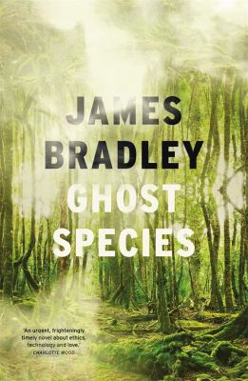
Ghost Species by James Bradley

Synopsis
When scientist Kate Larkin joins a secretive project to re-engineer the climate by resurrecting extinct species, she becomes enmeshed in another, even more clandestine program to recreate our long-lost relatives, the Neanderthals. But when the first of the children, a girl called Eve, is born, Kate finds herself torn between her duties as a scientist and her urge to protect their time-lost creation.
Set against the backdrop of hastening climate catastrophe, Ghost Species is an exquisitely beautiful and deeply affecting exploration of connection and loss in an age of planetary trauma. For as Eve grows to adulthood she and Kate must face the question of who and what she is. Is she natural or artificial? Human or non-human? And perhaps most importantly, as civilisation unravels around them, is Eve the ghost species, or are we?
Thrillingly original, Ghost Species is embedded with a deep love and understanding of the natural world.

Discussion questions
- Charlotte Wood called Ghost Species ‘an urgent, frighteningly timely novel about ethics, technology and love’. Would you agree with this summation? Did you feel the balance of the novel landed on one of these areas more than others?
- Why do you think Kate agreed to participate in this experiment: scientific ego to be the first, distraction from her own personal doubts and fears, to wind back inevitable climate catastrophe, or something else?
- Do you believe Davis was honest in his explanation for the motivations behind the creation of Eve? What do you think James Bradley was exploring in his set up of the Foundation?
- There are some big questions at the core of Ghost Species that arise in so many parts of life. Do we have the right to alter nature, regardless of whether it is just because we can, or for higher purposes?
- Early responses have classified Ghost Species as ‘cli-fi’. Is climate fiction a genre, or are Bradley and his peers doing what novelists have always done, written in response to the times in which they live?
- Did you read Ghost Species as a speculative narrative, or is it a contemporary novel?
- What is it that we really believe sets ‘human’ apart from Neanderthal, or any other species or animal?

Discussion questions from https://www.penguin.com.au/book-clubs/2617-ghost-species-book-club-notes

