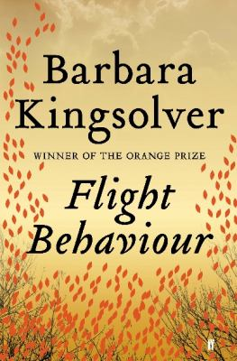
Flight Behaviour by Barbara Kingsolver

Synopsis
Set in the present year in the rural community of Feathertown, Tennessee, Flight Behavior tells the story of Dellarobia Turnbow, a petite, razor-sharp 29-year old who nurtured worldly ambitions before becoming pregnant and marrying at seventeen. Now, after more than a decade of tending small children on a failing farm, oppressed by poverty, isolation, and her husband’s antagonistic family, she has mitigated her boredom by surrendering to an obsessive flirtation with a handsome younger man. In the opening scene she is headed for a secluded mountain cabin to meet this man and initiate what she expects will be a self-destructive affair.
The tryst never happens. Instead she walks into something on the mountainside she cannot explain or understand: a forested valley filled with silent red fire that appears to Dellarobia to be a miracle. Her discovery is both beautiful and terrible, and elicits explanation of every type.
After years lived entirely in the confines of one small house, Dellarobia finds her path suddenly opening out, chapter by chapter, into blunt and confrontational engagement with her family, her church, her town, her continent, and finally the world at large. Over the course of a single winter her life will become the property of the planet and also, possibly for the first time, securely her own.

Discussion questions
- Talk about the characters names—Dellarobia, Preston, Cordelia, Dovey, Ovid Byron, Cub, Bear, Hester. How does the author’s choice of nomenclature suit her characters?
- Talk about Della’s relationships with the various people in her life: Cub, Hester, Pastor Bobby, Dovey, Ovid Byron. What do her experiences teach her about herself and life?
- How does Della react when she first sees the Monarchs? What greater meaning do the butterflies hold for her? How is she like the butterflies? How does finding them transform her life?
- As news of her discovery spreads, what are the reactions of her in-laws and her neighbours? How do they view Della? What are their impressions of the scientists and tourists?
- Flight Behavior illuminates the conflicting attitudes of different classes towards nature and the idea of climate change. How does each side see this issue? Where do they find common ground?
- How is media both a help and a hindrance in our understanding of social issues? How does it offer clarity and how does it add confusion? How is the media portrayed in Flight Behavior?
- At the end of the novel, Dellarobia recalls when Ovid Byron first met Preston and declared the boy a scientist. “A moment, Dellarobia now believed, that changed Preston’s life” Have you ever had such a defining moment in your life? Was there a special person who influenced you and helped guide or shift the course of your life?
- What do you think will happen to Dellarobia, Preston, and Cordelia?
Discussion questions from https://www.readinggroupguides.com/reviews/flight-behavior/guide

