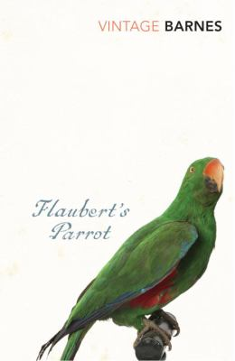
Flaubert’s Parrot by Julian Barnes

Synopsis
Flaubert's Parrot tells the story of Geoffrey Braithwaite, an English doctor who is obsessed with Gustave Flaubert. Geoffrey states that he has three stories to tell: Flaubert's, his own, and his wife Ellen's. The novel is comprised partly of fiction and partly of literary criticism, as the book traces Geoffrey's search for the "facts" about Flaubert and his work. Geoffrey discovers that two museums containing items of Flaubert's claim to own the stuffed parrot that Flaubert once borrowed from the Museum of Natural History. Geoffrey discovers, in the last chapter, that the museums each choose one parrot from a collection of fifty, not knowing which parrot Flaubert had really borrowed.
In his search for Flaubert, Geoffrey discovers that the great author was involved with Juliet Herbert, although Ed Winterton destroyed the evidence of their affair. Geoffrey learns about the lives that Flaubert did not lead and the books that he did not write. Geoffrey dives into the criticisms of Flaubert and his faults. Through Flaubert's life and work, Geoffrey tries to make sense out of his own life.
Geoffrey's obsession with Flaubert covers his own hurt, confusion, and pain over his wife's death and his relationship with her. Ellen, his wife, had a number of affairs during their marriage and Geoffrey has conflicted feelings about her. Geoffrey tries to decide whether they were happy or unhappy in their marriage and if his wife really loved him or not. Geoffrey is also tormented by the fact that he shut off her life support, essentially killing her, even though he knows that there was no hope for her.

Discussion questions
- Discuss how art and life intermingle in the novel. What is Barnes trying to tell us about this relationship? How do both Flaubert and Geoffrey react to it?
- Discuss why Geoffrey is searching for an understanding of Flaubert.
- The novel features a number of unconventional chapters for a work of fiction. Why do you think Barnes includes these formats?
- Compare and contrast Louise Colet and Ellen Braithwaite. Do you think the chapter from Louise's perspective is meant as a way for Geoffrey to look back on his wife? Why or why not?
- Compare and contrast Geoffrey and Flaubert. In what ways are the two men similar? Different?
- Discuss the idea of the past as something shifting and uncertain.
- How does the search for the truth about the two parrots mirror Geoffrey's search for the truth about his marriage?

Discussion questions from http://www.bookrags.com/studyguide-flauberts-parrot/topicsfordiscussion.html#gsc.tab=0

