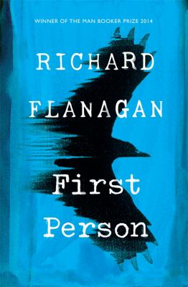
First Person by Richard Flanagan

Synopsis
About to go to trial for defrauding the banks of millions, con man and corporate criminal Siegfried Heidl offers broke writer Kif Kehlmann a deal he can’t refuse: $10,000 for Kehlmann to ghost write his memoir in six weeks.
As the deadline draws closer and Heidl grows increasingly erratic, Kehlmann becomes unsure if he is ghost writing a memoir or if Heidl is rewriting him – his life, his future.
As tension slowly mounts, boundaries and identities blur, everything that was certain grows uncertain, and the young writer finds himself no longer sure if he is Kif Kehlmann – or a murderous criminal.

Discussion questions
- What do we learn about Heidl’s crimes? What remains opaque? Why might Flanagan have chosen not to reveal all of the details?
- Examine the connection between deception, truth, and trust as it is depicted in the novel. Is there such thing as absolute truth? To what extent is truth defined by belief? How does Heidl exploit the trusting nature of others?
- Describe Heidl’s worldview. How does he understand goodness, evil, and morality? What motivates him? What reasons does he give for wanting to end his life?
- Explore the theme of memory as it is depicted in the novel. How does memory operate? Are memories ever reliable? What purpose do memories serve?
- Examine Kif’s relationship with Suzy. What first draws him to her? How does his work with Heidl—and his role in his death—affect their relationship?
- Explore the theme of success as it is depicted in the novel. What constitutes success and what are its markers? What is the cost of success? Does Kif ever achieve success? Consider, as you answer this question, Kif’s work with Heidl, his own unpublished novel, and his work in the television industry.
- Examine Kif’s career in television. How does he get his big break? How does he characterize the culture of the industry? Does he find happiness working in television? Why or why not?
- What is Dying to Know, and why do you think Kif calls it “the closest [he’s] ever come to autobiography” (page 321)?
- Consider the novel’s title. To whom—or what—do you think it refers?
- How do you interpret the conclusion of the novel? Is this the ending you expected? What does it suggest about Kif’s reliability as a narrator?
Discussion questions from https://www.penguinrandomhouse.com/books/561549/first-person-by-richard-flanagan/readers-guide/

