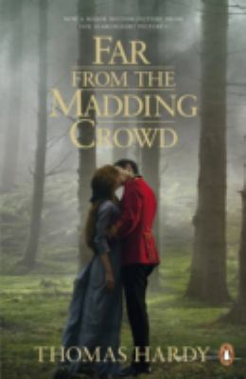
Far From the Madding Crowd by Thomas Hardy

Synopsis
Gabriel Oak is only one of three suitors for the hand of the beautiful and spirited Bathsheba Everdene. He must compete with the dashing young soldier Sergeant Troy and the respectable, middle-aged Farmer Boldwood. And while their fates depend upon the choice Bathsheba makes, she discovers the terrible consequences of an inconstant heart.
Far from the Madding Crowd was the first of Hardy's novels to give the name Wessex to the landscape of south-west England, and the first to gain him widespread popularity as a novelist. Set against the backdrop of the unchanging natural cycle of the year, the story both upholds and questions rural values with a startlingly modern sensibility. This new edition retains the critical text that restores previously deleted and revised passages.

Discussion questions
- According to the scholar Howard Babb, Hardy’s depiction of Wessex “impinges upon the consciousness of the reader in many ways . . . as mere setting, or a symbol, or as a being in its own right.” How does environment serve as an integral part of this novel?
- The title of Far from the Madding Crowd, borrowed from Thomas Gray’s “Elegy Written in a Country Churchyard, ” celebrates the “cool, sequestered” lives of rural folks. Is the title ironic or appropriate?
- The rustics who work the land, tend the sheep, and gather at Warren’s malt house have been likened to a Greek chorus. Can you support this analogy? What function do the rustics serve in the novel?
- Time is a theme that weaves throughout the story. One example may be found in Chapter XVI, when Frank Troy stands rigidly in All Saints Church awaiting Fanny’s delayed arrival while a “grotesque clockwork” agonizingly marks each passing moment. Where else does Hardy employ the theme of time, and what purpose does it serve?
- In Chapter IV, Bathsheba tells Gabriel, “I want somebody to tame me; I am too independent: and you would never be able to, I know.” How is Bathsheba “tamed” over the course of the novel, and who is responsible for her transformation?
- How does the subordinate plot concerning Fanny Robin and Sergeant Troy serve as a contract to the main storyline?
- What do Bathsheba Everdene and Fanny Robin have in common, and how do they differ? And what does Hardy’s portrayal of these two women reveal about Victorian moral standards?
- In Gabriel Oak, Sergeant Troy, and Farmer Boldwood, Hardy has depicted three very different suitors in pursuit of Bathsheba Everdene. What distinguishes each of these characters, and what values does each of them represent?
Discussion questions from https://www.penguinrandomhouse.com/books/75307/far-from-the-madding-crowd-by-thomas-hardy/9781551997407/readers-guide

