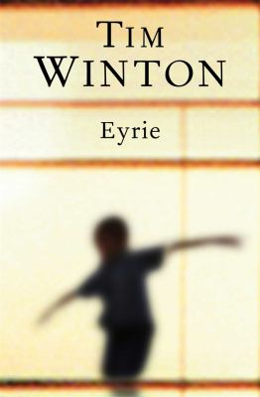
Eyrie by Tim Winton

Synopsis
Tom Keely's reputation is in ruins. And that's the upside.
Divorced and unemployed, he's lost faith in everything precious to him. From his seedy high-rise flat Keely looks down at a society from which he's retired hurt and angry, well past caring. He has cut himself off, and intends to keep it that way, but he cannot avoid entanglement with the neighbours: a woman from his past, a boy the likes of which he's never met before. Two strangers leading a life beyond his experience and into whose orbit he falls despite himself.
But the pair come trailing a dangerous past of their own, and Keely is soon immersed in a world that threatens to destroy everything he has learnt to love.

Discussion questions
- Keely thinks that applying the concept of goodness to himself is 'something of a stretch', that he's 'righteous in a misanthropic way' (page 42). Is he too hard on himself? What drives him, do you think? What's behind his refusal to seek medical advice?
- What do you make of Kai? Discuss his character in terms of his behaviour, his affectlessness, his seriousness, his dreams, his intelligence, his language use, his uncanny characteristics, his obsession with birds, his relationship with Gemma, his social isolation, his fixation with death. What do you think is going on between him and Keely?
- Do you agree with Doris that Gemma's hard life has made her manipulative? Is the latter's relationship with Keely driven by nostalgia and physical need, or something else? What do you think she's doing when she goes out dressed to the nines?
- One of the questions Eyrie poses is how best to help – others, yourself, the planet. Discuss the many ways in which this issue is presented in the novel. Is Doris right not to give Gemma the money demanded by Stewie, in your opinion?
- What does Eyrie show about social class in contemporary Australia? Discuss this particularly in respect of the diverging paths of Doris and Gemma, both women of working-class origin; in respect of Doris and Keely's differing views of themselves; and in respect of the subclass represented by Stewie and Clappy.
- What is your opinion of Harriet? Is she, also, perhaps too hard on herself? Was she too hard on Keely? Part of his backstory rather than a protagonist in the novel, she is nevertheless a key part of his thoughts: what does her character suggest about the quality of forgiveness?
- A large part of Eyrie is a father-son story: Keely's relationship with his own father, his father-like role to Kai. What does the novel have to say about men and fatherhood? And how alike do you find Keely and his father? How similar are their trajectories?
Synopsis/Discussion questions from https://www.penguin.com.au/books/eyrie-9780143571346/book-clubs/21-eyrie-reading-notes

