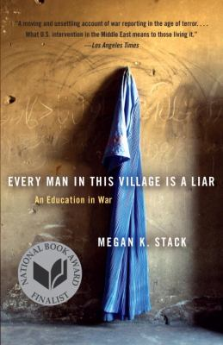
Every Man in This Village Is a Liar by Megan Stack

Synopsis
A few weeks after the planes crashed into the World Trade Center, journalist Megan K. Stack was thrust into Afghanistan and Pakistan, dodging gunmen, prodding warlords for information, and witnessing the changes sweeping the Muslim world.
Every Man in This Village Is a Liar is her riveting story of what she saw in the combat zones and beyond. She relates her initial wild excitement and slow disillusionment as the cost of violence outweighs the promise of democracy; she records the raw pain of suicide bombings in Israel and Iraq; and, one by one, she marks the deaths and disappearances of those she interviews.

Discussion questions
- Every Man in This Village Is a Liar is, in many ways, a book about telling the truth. What truths does Megan Stack discover and reveal throughout the course of the book? Why is it so important to tell the truth amid the lies of war?
- Who are some of the most memorable people Stack meets during her reporting on the Middle East? Why is it so important to tell the stories of individual human beings caught up in the suffering, pain, and grief of war?
- Every Man in This Village Is a Liar is subtitled An Education in War. In what ways is Stack educated by war? In what ways does she educate her readers about the realities of war?
- How does Every Man in This Village Is a Liar challenge conventional views of the Middle East?
- Stack ends the book by reminding readers what war has taught her: “You can survive and not survive, both at the same time” (p. 245). What is the meaning of this paradoxical statement?
- What are some of the most harrowing moments in the book? What effect do they have on Stack and on her readers?
- Stack concludes that the “war on terror never really existed,” that it was “essentially nothing but a unifying myth for a complicated scramble of mixed impulses and social theories and night terrors and cruelty and business interests, all overhung with the unassailable memory of falling skyscrapers” (p. 3). Is she right about this? In what sense is the war on terror unreal?
- Every Man in This Village Is a Liar plunges readers into the visceral particulars of the war in Iraq and other ongoing conflicts in the region, giving a vivid sense of the texture of war. But what larger points does the book make about war, America’s involvement in the Middle East, the treatment of women in Islamic countries, and other issues?

Discussion questions from https://www.penguinrandomhouse.com/books/171483/every-man-in-this-village-is-a-liar-by-megan-k-stack/9780767930345/readers-guide/

