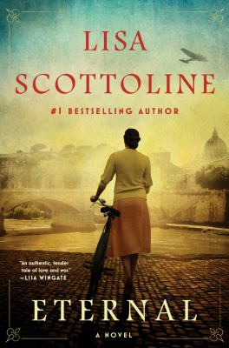
Eternal by Lisa Scottoline

Synopsis
Elisabetta, Marco and Sandro grow up as the best of friends despite their differences. Elisabetta is a feisty beauty who dreams of becoming a novelist; Marco the brash and athletic son in a family of professional cyclists; and Sandro a Jewish mathematics prodigy, kindhearted and thoughtful, the son of a lawyer and a doctor.
Their friendship blossoms to love, with both Sandro and Marco hoping to win Elisabetta's heart. But in the autumn of 1937, all of that begins to change as Mussolini asserts his power, aligning Italy's Fascists with Hitler's Nazis and altering the very laws that govern Rome. In time, everything that the three hold dear --- their families, their homes and their connection to one another --- is tested in ways they never could have imagined.
As anti-Semitism takes legal root and World War II erupts, the threesome realizes that Mussolini was only the beginning. The Nazis invade Rome, and with their occupation come new atrocities against the city's Jews, culminating in a final, horrific betrayal. Against this backdrop, the intertwined fates of Elisabetta, Marco, Sandro and their families will be decided, in a heartbreaking story of both the best and the worst that the world has to offer

Discussion questions
- At the beginning of novel, Lisa Scottoline quotes the late Italian novelist Ignazio Silone, who said, ‘Let everyone, then, have the right to tell his story in his own way’ Why is it so important for Elisabetta to tell her own story --- and, particularly, to write it? Isn’t everyone’s life story compelling in some way? Did you ever have the urge to write or tell yours, if only for yourself and your family? Do you ever wish you knew more about the life story of your own parents?
- If you read the Author’s Note, you learned that some of the incidents in the novel were inspired by true events that took place in Mussolini’s ventennio and World War II. This applies to the horrific events as well as the inspiring ones. Were you aware of these events before reading the novel? Did any of the historical events surprise you?
- How do Sandro’s and Marco’s feelings for Elisabetta transform over the course of the novel? Why do you believe that each of them fell in love with her? What was their ultimate expression of this love? Do you think that Elisabetta ended up with the ‘right’ person? Whom would you choose?
- Eternal is a novel about families, too. Compare and contrast the parents of Marco, Elisabetta and Sandro. Each parent faced their own struggles and made what could be considered mistakes while raising their children, as all parents do. How were the three main characters affected by them? Why do you think their parents each made the decisions that they did?
- Discuss the meaning of the quote near the end of the novel ‘Hate was eternal, but above all, so was love.’ Take a look at this quote in the context of each of the surviving character’s lives and actions.

Synopsis/Discussion questions from https://www.readinggroupguides.com/reviews/eternal-by-lisa-scottoline/guide

