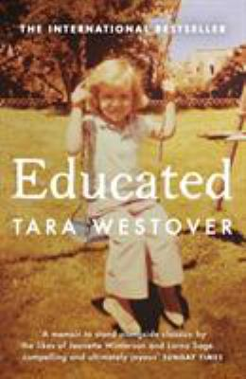
Educated by Tara Westover

Synopsis
Born to survivalists in the mountains of Idaho, Tara Westover was seventeen the first time she set foot in a classroom. Her family was so isolated from mainstream society that there was no one to ensure the children received an education, and no one to intervene when one of Tara’s older brothers became violent.
When another brother got himself into college, Tara decided to try a new kind of life. Her quest for knowledge transformed her, taking her over oceans and across continents, to Harvard and to Cambridge University. Only then would she wonder if she’d traveled too far, if there was still a way home.

Discussion questions
- Let’s discuss Tara’s parents. Why was her father so determined that they live off the grid? Do you believe he is undiagnosed bipolar? What are some of the signs that he showed this?
- Tara’s mother is an interesting figure. There are signs that she believes her husband and son goes too far—yet, she never seems to try to stop it, as far as we can tell. Let’s discuss her mother more.
- How did Tyler leaving to attend college completely change Tara’s perspective on what was expected out of her?
- There’s so much about religion in this book that we must discuss it. In what ways did both Lisa’s father and brother Shawn use religion as a way to manipulate the women of the family, especially Tara?
- In the Perfect in His Generations chapter, Tara’s father shows a bit more layers. He seems completely against her singing and acting in part, yet he continues to drive her to rehearsal and gives her feedback on her performances. What do you think was going on with his back and forth attitude about her performing?
- Shawn is violent, cruel and ignorant. Why was his violent behavior allowed? What do you think was truly going on with how he treated Tara? How did his jealousy of her impact his horrible actions? Let’s talk about the significance of her brother calling her a “whore” without any kind of pushback from her parents. Why did he call women “fish eyes” as an insult?
- When did Tara truly start to understand that she came from a troubled background and that her family’s behavior up until this point was wrong? How did getting an education help Tara see the truth about her family?
- Where do you think this leaves Tara now? Is there any hope of reuniting with her family? And even better question, should she?
- Did this story make you feel hopeful? Why or why not?

Discussion questions from https://bookclubchat.com/books/book-club-questions-for-educated-by-tara-westover/

