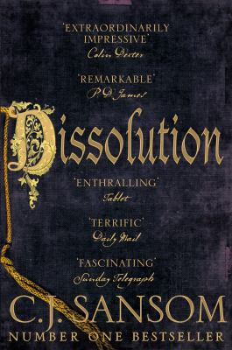
Dissolution by C.J. Sansom

Synopsis
The year is 1537, and the country is divided between those faithful to the Catholic Church and those loyal to the king and the newly established Church of England.
When a royal commissioner is brutally murdered in a monastery on the south coast of England, Thomas Cromwell, Henry VIII’s feared vicar general, summons fellow reformer Matthew Shardlake to lead the inquiry. Shardlake and his young protégé uncover evidence of sexual misconduct, embezzlement, and treason, and when two other murders are revealed, they must move quickly to prevent the killer from striking again.

Discussion questions
- Was Matthew Shardlake a truly naïve character, or was he simply in a deep state of denial with regard to Thomas Cromwell's style of governing?
- Can you imagine what your life might have been like during this period of history? Elaborate on the different ways in which the author evoked Tudor England, particularly London.
- Do you think an individual with a humpback could have risen to a commissioner's position at a time when his physical handicap was-to many people-bad luck? Why do you think the author chose to saddle Shardlake with this deformity? Did you feel sorry for him? Why or why not?
- Did you feel sexual tension between Alice and Shardlake? If so, was it authentic or do you think Alice manufactured a faux physical attraction to manipulate Shardlake? Cite examples from the novel that support your theory.
- Choose one word, as quickly as possible, to describe each of the three main characters: Shardlake, Mark Poer, and Alice. Once you have done this, elaborate on the complexities, or lack of complexities, of these individuals.
- Choose one word, as quickly as possible, to describe each of the three main characters: Shardlake, Mark Poer, and Alice. Once you have done this, elaborate on the complexities, or lack of complexities, of these individuals.
- A "red herring" is a device used in mysteries to throw the reader off the track of the true perpetrator. What, or who, were Mr. Sansom's red herrings?
- What characters from Dissolution would you be interested in seeing again in future Matthew Shardlake mysteries? Why?
- Did you feel relief upon learning that Mark Poer and Alice survived? Why or why not?

Discussion questions from https://www.readinggroupguides.com/reviews/dissolution/guide

