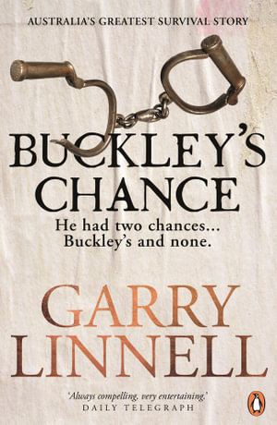
Buckley’s Chance by Garry Linnell

Theme

Overcoming insurmountable odd

- Napoleonic wars
- Sentence to hang
- Life in prison
- Survived the ship journey
- Hated cap and left at
- Circuit at Port Phillip – walked from Sorrento to Endeavor Heads
- Kept going when other turned back

Colonisation – Wadawurrung people (two worlds)
Much of the book told the story of the early days of the colonies of Victoria and Tasmania. The research in the area was expansive and conventional. Much less of the book told the story of when Buckley was living with the Wadawurrung. Could this have been done better
Fasted land grab in the history

Growth and origin of the city of Melbourne

Characters

William Buckley
Buckley was the thread that pulled together this history of industrial England, revolutionary France, penal Tasmania and colonial Victoria. (indigenous Australia) Was this Buckley’s story or was this a history of place and time?
Denied having wife and children??? Is this really possible?
Assimilated into Wd country.
Moved to Tasmainia and married.
Secured pardon when came back from the bush

John Pasco Fawkner
- Political operator – despised Buckley.

John Batman
We all know John Batman as the man who thought the Yarra “a great place for a village”. How do you think Batman in is book
Hired bucly as interprator for peaceful getting of land. 20 pounds a year – did not last – tricks of the white man – trapped between 2 cultures.

John Morgan
Bankrupted editor who tried to cash in on William Buckley’s story.

Setting
- England
- Ship
- Colony
- Bush

Writing Style
- Writing to Buckly

