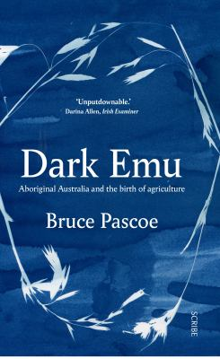
Dark Emu by Bruce Pascoe

Synopsis
Dark Emu argues for a reconsideration of the 'hunter-gatherer' tag for pre-colonial Aboriginal Australians and attempts to rebut the colonial myths that have worked to justify dispossession.
Accomplished author Bruce Pascoe provides compelling evidence from the diaries of early explorers that suggests that systems of food production and land management have been blatantly understated in modern retellings of early Aboriginal history, and that a new look at Australia's past is required.

Discussion questions
- What three words would you use to best describe this book?
- What do you think the title means?
- What did you learn in the book that you didn't know before?
- Did the book meet your expectations?
- What was your favourite quote/sentence/paragraph in the book?
- If you could ask the author a question, what would it be?
- Did any part of the book elicit a strong emotional reaction?
- Did the book change your opinions on anything? If so, what?
- After reading the book, do you agree or disagree with the author, in regards to Aboriginal people historically being more than the ‘hunter-gatherer’ they were labelled as?
- Would you recommend this book to someone?

Discussion questions from https://www.littleblackduckaus.com/single-post/2018/03/18/discussion-questions-dark-emu-black-seeds-agriculture-or-accident

