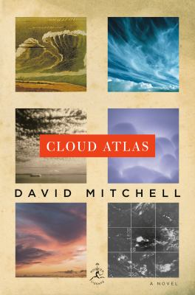
Cloud Atlas by David Mitchell

Synopsis
Mitchell weaves history, science, humor, and suspense through six separate but related narratives, each set in a different time and place, each written in a different prose style, and each broken mid-action only to be concluded in the second half of the book.

Discussion questions

1. What is Cloud Atlas about? What are the questions the book explores—its primary thematic concerns?
2. Is this a cautionary tale...a prognosis...a diagnosis? In Mitchell's tales, what do humans seem bent on doing to one another...and why? With little left at the end, what, if anything, remains?
3. Why does Mitchell use the structure he does? What might he be hoping to achieve through the six (or twelve) interrelated stories, each based on a specific genre: epistolary, mystery, farce, sci-fi, post-apocolyptic? What is the effect, then, of reversing the tales and going backward?
4. How do each of the tales fit together...forward and backward. Put the pieces of the puzzle together—showing how one story links to another. How, for instance, is Luisa Rey in t connected to Frobisher?
5. What is the significance of the title, "Cloud Atlas"?
6. Which was your favourite tale...and least favourite?
7. What was your experience reading the work: did you find the structure disruptive and confusing...and did you enjoy picking up the linkage between the stories and seeing how it played out by the end?
(Questions taken from litlovers.com)

Publisher credit if appropriate

