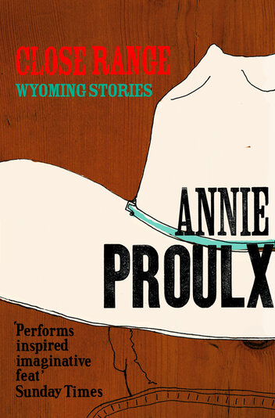
Close Range : Wyoming Stories by Annie Proulx

Synopsis
Annie Proulx's masterful language and fierce love of Wyoming are evident in this collection of stories about loneliness, quick violence, and wrong kinds of love. These are stories of desperation, hard times, and unlikely elation, set in a landscape both brutal and magnificent. Enlivened by folk tales, flights of fancy, and details of ranch and rural work, they juxtapose Wyoming's traditional character and attitudes—confrontation of tough problems, prejudice, persistence in the face of difficulty—with the more benign values of the new west.

Discussion questions
- The Half Skinned Steer
In the story told by Mero's old man's girlfriend, the half-skinned steer becomes a terrible fate Tin Head knows he can't escape. What is Mero's half-skinned steer? How was he marked by it and by his Wyoming origins? What is the nature of Mero's journey?
- The Mud Below
What drives Diamond, raised in town and meant for better things, to make himself into a rodeo bull rider? Are rodeo performers real cowboys? Does not knowing who his father is force him to invent a persona for himself? What are his feelings toward his mother, his young brother?
- Job History
Does the title, "Job History" hold any irony? What do the jobs the members of this rural family hold tell us about their lives and opportunities? Do we learn more about them than the story's brevity and matter-of-fact style would suggest?
- The Blood Bay
This story is a twist on an old folk tale, but here given a Wyoming setting and characters. What does Proulx's adaptation of this tale tell you about the collection as a whole? Are you supposed to read these stories as a literal reflection of life in the west?
- People in Hell Just Want A Drink of Water
Compare the Dunmires and the Tinsleys -- each family's character and sensibilities, what each values, how they see the world, etc. What do their differences say about the error of stamping all rural people as similar in nature?
- A Lonely Coast
Did this story's depiction of contemporary small-town Wyoming surprise you? Do you think of drugs as a rural problem? What are the hungers, behaviors, and social factors that drive this story?
- Brokeback Mountain
Both Ennis and Jack convince themselves that they aren't gay, and tell one another lies about the women in their lives. Is either man threatened by the other's relationships with women? Why is it so hard for Ennis to ask Jack if he was with other men in Mexico? How does Jack's disclosure affect their relationship?

Discussion questions from https://www.simonandschuster.com/books/Close-Range/Annie-Proulx/9780684852225

