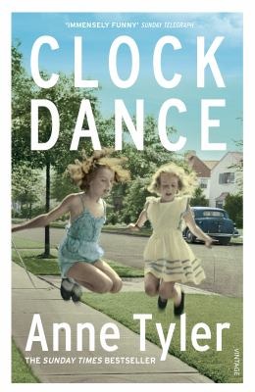
Clock Dance by Anne Tyler

Synopsis
Willa Drake can count on one hand the defining moments of her life.
In 1967, she is a schoolgirl coping with her mother's sudden disappearance. In 1977, she is a college coed considering a marriage proposal. In 1997, she is a young widow trying to piece her life back together. And in 2017, she yearns to be a grandmother but isn't sure she ever will be.
Then, one day, Willa receives a startling phone call from a stranger. Without fully understanding why, she flies across the country to Baltimore to look after a young woman she's never met, her nine-year-old daughter, and their dog, Airplane.
This impulsive decision will lead Willa into uncharted territory—surrounded by eccentric neighbors who treat each other like family, she finds solace and fulfillment in unexpected places.

Discussion questions
- What was your initial take of the passenger who threatens Willa on the airplane: "This is a gun, and it's loaded. Move and I shoot"? Why might Anne Tyler have incorporated the plane incident—placing it early on—in the novel? What does it reveal, if anything, about Willa's character?
- What makes Willa agree to head to Baltimore in order to take care of almost complete strangers?
- Talk about the bond that develops between Willa, nine year old Cheryl and Cheryl's mother, Denise, who has no difficulty depending on Willa's generosity. And how is Willa's personality perfectly shaped to fall in with this little family of two?
- Willa confides to Denise that, while she's not asked him, she hoped her son would have offered to pick her up before dinner. Denise responds with "But why just hope? Why do you go at things so slantwise?" What does Denise mean—and where else does Willa "go at things slantwise"?
- Discuss how Willa's real family treats her, especially, say, her son Sean?
- A neighbor tells Willa: "Figuring out what to live for. That's the great problem at my age." Discuss in terms of this novel or in terms of real life (maybe even your own)?
- What does Willa find—in life and within herself—in Baltimore?
- The book's title, "Clock Dance," comes from the game young Cheryl plays with two friends. What might the thematic significance of the title be?
- The plot of Clock Dance contains little in the way of conflict. Did you find that refreshing, even a bit of a relief? Were you engaged as you read the book? Or did you find the novel's lack of conflict and suspense uninteresting?
Synopsis/Discussion questions from https://www.litlovers.com/reading-guides/13-reading-guides/fiction/11327-clock-dance-tyler?showall=1

