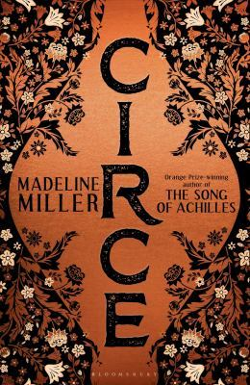
Circe by Madeline Miller

Synopsis
In the house of Helios, god of the sun and mightiest of the Titans, a daughter is born. But Circe is a strange child --- not powerful, like her father, nor viciously alluring like her mother. Turning to the world of mortals for companionship, she discovers that she does possess power --- the power of witchcraft, which can transform rivals into monsters and menace the gods themselves.
Threatened, Zeus banishes her to a deserted island, where she hones her occult craft, tames wild beasts, and crosses paths with many of the most famous figures in all of mythology, including the Minotaur, Daedalus and his doomed son Icarus, the murderous Medea and, of course, wily Odysseus.
But there is danger, too, for a woman who stands alone, and Circe unwittingly draws the wrath of both men and gods, ultimately finding herself pitted against one of the most terrifying and vengeful of the Olympians. To protect what she loves most, Circe must summon all her strength and choose, once and for all, whether she belongs with the gods she is born from, or the mortals she has come to love.

Discussion questions
- Circe struggles to find a place for herself as a woman in a man’s world. What parts of her experience resonate with modern-day challenges that women face?
- Circe wonders if parents can ever see their children clearly. She notes that so often when looking at our children “we see only the mirror of our own faults.” What parts of herself does she see when she looks at Telegonus? What are her strengths and weaknesses as a parent to him?
- Circe’s sister, Pasiphaë, begins the novel as a major antagonist. How does our perspective of her change after Circe’s visit to Crete?
- Circe begins the novel feeling very close to her brother, Aeëtes. Why do their paths diverge so wildly? Why do you think he makes the choices he does?
- There are numerous references to crafts in the novel, including weaving, carpentry and metal-working. What role does craft play in Circe’s story?
- Circe encounters several famous figures from Greek myth. Were any of their portrayals surprising?
- How does Circe’s relationship with her father change over the course of the book? What do you make of their final conversation?
- We see numerous powerful characters abusing their positions throughout the story. Are power and abuse necessarily connected? Are there any models for power without cruelty in the novel?
- Circe’s gift is transformation. How does she transform from the beginning of the novel to the end? Why does she ultimately choose the path she does?

Discussion questions from https://www.readinggroupguides.com/reviews/circe/guide

