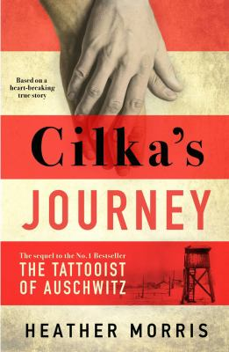
Cilka’s Journey by Heather Morris

Synopsis
Cilka is just sixteen years old when she is taken to Auschwitz-Birkenau Concentration Camp in 1942, where the commandant immediately notices how beautiful she is. Forcibly separated from the other women prisoners, Cilka learns quickly that power, even unwillingly taken, equals survival.
When the war is over and the camp is liberated, freedom is not granted to Cilka: She is charged as a collaborator for sleeping with the enemy and sent to a Siberian prison camp. But did she really have a choice? And where do the lines of morality lie for Cilka, who was send to Auschwitz when she was still a child?
In Siberia, Cilka faces challenges both new and horribly familiar, including the unwanted attention of the guards. But when she meets a kind female doctor, Cilka is taken under her wing and begins to tend to the ill in the camp, struggling to care for them under brutal conditions. Confronting death and terror daily, Cilka discovers a strength she never knew she had. And when she begins to tentatively form bonds and relationships in this harsh, new reality, Cilka finds that despite everything that has happened to her, there is room in her heart for love.

Discussion questions
- Is Cilka’s prison sentence in Vorkuta as punishment for “sleeping with the enemy” in the concentration camp cruel? Was she forced into this role in order to survive as a mere sixteen-year-old girl? How might Cilka’s outward behavior compare to her inner intentions?
- “What you are doing, Cilka, is the only form of resistance you have—staying alive. You are the bravest person I have ever known, I hope you know that.” (Chapter 32) Is Lale right? Is Cilka brave, and were her acts of resistance the best course of action she had? What does Cilka feel guilty about or complicit in? How is she suffering because of it?
- How do the women form a sisterhood or join in solidarity? Do you believe there is something universal about what they do? From snowy rescues to smuggled food—even Elena’s self-inflicted burn in order to get a message to Cilka—how do the women look out for one another?
- How does Yelena help and advocate for Cilka? What chances and tests is Cilka given because of Yelena’s attentions? How does Cilka repay her faith and kindness? Also, why do you think Yelena would choose to serve in such a brutal place?
- Discuss Josie’s desperation regarding her baby Natia’s fate, and what lies ahead for them both after the two-year mark? How does Cilka ensure her safe transfer?
- How does Cilka find her calling with her ambulance work? How did she spur others to be their best selves? On the other hand, what sexist abuse did she face while performing such technical and important work?
- How are Cilka and Alexandr joined together? How does she administer to him and what new hope does he offer for her future? What risks? Were you surprised by their reunion on the train platform?

Synopsis/Discussion questions from https://us.macmillan.com/books/9781250265708/cilkasjourney

