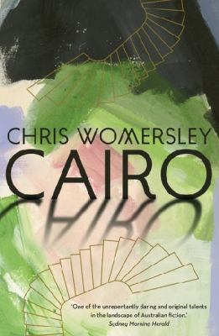
Cairo by Chris Womersley

Synopsis
Frustrated by country life and eager for adventure and excitement, seventeen-year-old Tom Button moves to the city to study. Once there, and living in a run-down apartment block called Cairo, he is befriended by the eccentric musician Max Cheever, his beautiful wife Sally, and their close-knit circle of painters and poets. As Tom falls under the sway of his charismatic older friends, he enters a bohemian world of parties and gallery openings.
Soon, however, he is caught up in more sinister events involving deception and betrayal, not to mention one of the greatest unsolved art heists of the twentieth century: the infamous theft of Picasso’s Weeping Woman.
Set among the demimonde — where nothing and nobody is as they seem — Cairo is a novel about growing up, the perils of first love, and finding one’s true place in the world.

Discussion questions
- What lessons does Tom Button learn from his time at Cairo? Are they useful lessons to take into adulthood?
- Has there been an event (or events) in your own life that you think of as having acted as a bridge into adulthood?
- At one point, Max Cheever declares: ‘Their rules don’t apply to us.’ Do you think artists are exempt from some social conventions? Should they be?
- Gertrude Degraves tells Tom: ‘The common perception of the heroic artist is almost exclusively male.’ Do you think this is true? Why or why not? How many famous female artists can you name?
- Is forgery really a ‘purer’ way of making art, as Gertrude suggests?
- Is it true, as Gertrude says, that people judge art more according to their perception of the artist, rather than the work itself? If so, is this a bad thing?
- Max declares Australia to be in the thrall of the ‘cult of the ordinary man’. Do you think he is right about that in regards to the 1980s? And now? If so, does it matter?
- What do you think becomes of Max, Sally, Edward, Gertrude, and Anna Donatella?
- What do you think the note and gift from Sally to Tom at the end of Cairo signify? What are her real feelings for Tom?
- Where has the real Weeping Woman painting ended up, in your opinion?
Synopsis/Discussion questions from https://a1b29423df1c76886901-30f50311cbe25c4d753e0084f1029763.ssl.cf4.rackcdn.com/Cairo_ChrisWomersley_BCN.pdf

