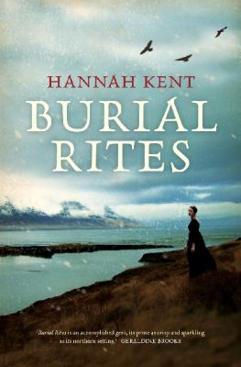
Burial Rites by Hannah Kent

Synopsis
Set against Iceland’s stark landscape, Hannah Kent brings to vivid life the story of Agnes, who, charged with the brutal murder of her former master, is sent to an isolated farm to await execution.
Horrified at the prospect of housing a convicted murderer, the family at first avoids Agnes. Only Tóti, a priest Agnes has mysteriously chosen to be her spiritual guardian, seeks to understand her. But as Agnes’s death looms, the farmer’s wife and their daughters learn there is another side to the sensational story they’ve heard.
Discussion questions
- What do you make of the historical documents (both real and fictionalized) that begin each chapter? How did these change or aid your understanding of Agnes’s story?
- Fate and destiny are major themes in this novel, for Agnes seems fated to have come to the end she does. Could she have escaped this destiny? Was there a turning point in her life that she might have avoided?
- Are Steina, Lauga and Margrét changed by Agnes’s time with them? Has her fate changed theirs in any way?
- Blöndal is the real villain of this piece. His dispassionate communications with those whom he controls are filled with venom and spite. What did you make of his decision to lodge Agnes with District Officer Jón and his family? What do you believe happened at Stóra-Borg that caused Blöndal to move Agnes to Kornsá?
- Tóti’s interest in Agnes’s case begins as a young cleric wanting to prove himself to his elders, to a sincere desire to defend a condemned woman. His growth in compassion and his readiness to stand up to his seniors is one of the most significant themes in this novel. Discuss.
- Agnes goes to her death holding Tóti’s hand, for they have discovered a deep need for each other. Is this story ultimately about the loneliness of our end in life? Or does it celebrate the comfort that a person can bring to the dying? Discuss.
- Hannah Kent calls her novel a ‘dark love letter to Iceland’ in her Acknowledgements. What does she mean by this? Did you read the novel in this way?

Synopsis/Questions from https://www.littlebrown.com/titles/hannah-kent/burial-rites/9780316243919/

