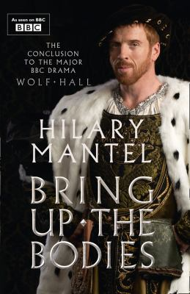
Bring Up the Bodies by Hilary Mantel

Synopsis
Though he battled for seven years to marry her, Henry is disenchanted with Anne Boleyn. She has failed to give him a son and her sharp intelligence and audacious will alienate his old friends and the noble families of England. When the discarded Katherine dies in exile from the court, Anne stands starkly exposed, the focus of gossip and malice.
At a word from Henry, Thomas Cromwell is ready to bring her down. Over three terrifying weeks, Anne is ensnared in a web of conspiracy, while the demure Jane Seymour stands waiting her turn for the poisoned wedding ring. But Anne and her powerful family will not yield without a ferocious struggle.
To defeat the Boleyns, Cromwell must ally with his natural enemies, the papist aristocracy. What price will he pay for Anne's head?.

Discussion questions
- How has Cromwell’s upbringing influenced him to become the shrewd and ambitious man that he is? What is the significance of Cromwell refusing to adopt the coat of arms belonging to a noble Cromwell family even as he widens the chasm between his father and himself? How does Cromwell view family and how is it different from his own experience growing up?
- How is King Henry VIII described in the novel? Is he self-serving, or does he truly believe in the validity of his actions? Does he come over as a sympathetic character?
- Katherine is accused by Cromwell of causing the split within the church, and of endangering her daughter Mary, by her stubborn resistance to the King’s wishes. Do you view Katherine as a relentless and self-indulgent queen or is she noble for staying true to her beliefs?
- King Henry had fawned over all three women (Katherine, Anne, Jane) at one point in time. His past actions indicate that he loved his former wives, yet each affair proves temporary. How does Henry view love? Why do the women in the novel endeavor to wear the “poisoned ring?”
- Anne Boleyn is accused of committing adultery and even incest. Could there be any truth in these accusations, or are they complete fabrications by her enemies? How does she change once she realizes she is in danger?’
- Does the novel make you reconsider your view of the Tudors?
- The story concludes with Cromwell’s claim that there are no endings, only beginnings. The country now has a new queen and a new leading family. What does this mean for England’s future? What do you think Cromwell’s role will be in the new order?
- The execution of Anne Boleyn is one of the most frightening moments in English history. Anne’s last words are scripted to appease the King. What do you think would have been Anne’s last words had there not been any consequences?
Discussion questions from https://us.macmillan.com/books/9781250024176/bringupthebodies

