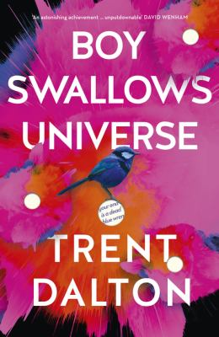
Boy Swallows Universe by Trent Dalton

Synopsis
Brisbane, 1984: A lost father, a mute brother, a mum in jail, a heroin dealer for a stepfather and a notorious crim for a babysitter. It's not as if Eli's life isn't complicated enough already. He's just trying to follow his heart, learning what it takes to be a good man, but life just keeps throwing obstacles in the way - not least of which is Tytus Broz, legendary Brisbane drug dealer.
But Eli's life is about to get a whole lot more serious. He's about to fall in love. And, oh yeah, he has to break into Boggo Road Gaol on Christmas Day, to save his mum.
A story of brotherhood, true love and the most unlikely of friendships, Boy Swallows Universe will be the most heartbreaking, joyous and exhilarating novel you will read all year.

Discussion questions
- Slim’s view of the world is that: ‘We all got a bit o’ good and a bit o’ bad in us…’ Discuss the ways in which characters in the novel are both good and bad at the same time.
- What do you think is the meaning of the red telephone, and the mysterious voice that speaks to Eli? Do good life lessons remain valid if delivered by evil men? What sort of man do you hope (or fear) Eli Bell will grow into?
- What do you think, ultimately, Eli Bell is searching for in life and in that secret room? Why do you think August chooses to be mute?
- Does the knowledge that much of this novel is based on Trent’s own life change your reading of the book? Enhance it? Or does it not make a difference?
- Do you think that the trauma that Mrs Birbeck talks about (p224) is a factor in Eli’s journey?
- Do you think the novel is optimistic or pessimistic about the world?
- Were there similarities or differences in the book to your own memories of 1980s suburban Australia?
- Discuss the idea that August may have knowledge of future events and how this is suggested and also at times debunked.
- ‘Do your time before it does you,’ says Slim. What does Eli take this to mean and how does he act on it?
- The novel presents an interesting view of adults from a child’s perspective. What does it say about adults and particularly adult men? And what does Eli learn from this?
Discussion questions from https://www.harpercollins.com.au/9781460757765/boy-swallows-universe/

