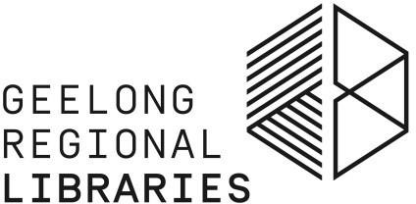

Book Club Fact Sheet

If you’re a member of a book club or would like to create one, Geelong Regional Library Corporation (GRLC) can help with kits of books specially chosen for book clubs available for loan.

Book Club Kits

GRLC is building a collection of Book Club Kits, with new titles added each year. Book Club Kits are available for loan to Book Clubs which join the library as group members.

Book Club kits cost $10 to loan, payable on pickup from branch.

Each kit contains 10-12 copies of the same book title, e.g. 12 copies of “Wuthering Heights”. The books are stored in a convenient carry bag. Please check the catalogue record for copy numbers, to ensure there are enough for your group.
Kits also include discussion notes which are also available on the library website https://www.grlc.vic.gov.au/learn/adult-learners/book-club-title-list. You can request additional printed copies of the discussion notes from your local library branch.
Book Club Kits may only be borrowed using a Book Club membership card. If a book is lost, standard library charges will apply.

Getting Started

You may already be part of a book club which would like to use the library’s Book Club Kits. If not, gather a group of up to 10 interested people to form a book club (the web provides a lot of information on how to start a book club). Give your Book Club a name
e.g. “Belmont Bookies”.

One person in your Book Club needs to volunteer as Coordinator. That person must be a resident of a GRLC municipality and a library member and will be asked to be responsible for all items in a kit, including borrowing and returns and organising payment for the kit and for any overdue, lost or damaged items.

Book Club Membership

The Coordinator will join up your book club with the library and a separate library card will be issued under the club’s name.
All Book Club members should be members of the Geelong Regional Library Corporation and have provided their library membership number to the Book Club Coordinator. Membership of the library service is free.

Choosing a Book Club Kit

A list of the library’s Book Club Kits can be found by searching the Geelong Regional Library Corporation catalogue.
Work through the list as a group and decide which titles you’d like to read. Make your selection as large as possible to help the Coordinator find an available kit for your discussion.
To borrow your kits, a request may be placed on one title each month. Please look for kits which are not checked out and don’t already have a request against them so that the kit arrives in time for your meeting. Allow at least one week for the kit to arrive.

Borrowing and returning a Book Club Kit

Book Club Kits can only be borrowed using a Book Club membership card and by placing a request in the catalogue. You will be notified when the Kit becomes available for collection at your nominated GRLC library. Ask for the kit at the library desk. Both borrowing and returning the kit needs to be done directly with library staff, rather than using self- checkout or the returns chute.
A Book Club should read one book at a time. A maximum of 2 kits can be on loan to a Book Club to allow a hand over period between last month and next month’s kits.
Book Club Kits must be returned as complete sets. Do not return books out of kits separately.
Book Club Kits are on loan for 6 weeks. This is to allow a 2 week period for pick up and return of the Kit. It is not possible to renew Book Club Kits, so the group needs to read and discuss the book within the period.

For more information, please speak to staff at your local library.

