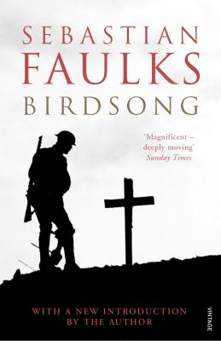
Birdsong by Sebastian Faulks

Synopsis
The story begins in Amiens, northern France in 1910. A young Englishman, Stephen Wraysford, is on attachment from London, working in the textile industry and lodging with the Azaire family. René Azaire runs a large factory where Stephen works; his second wife Isabelle is a woman of unfulfilled hopes, ill-treated by her husband. Stephen develops a concealed passion for Isabelle. At first, she resists; but this only intensifies his feeling, which she soon comes to share. Stephen and Isabelle flee together to Provence. She becomes pregnant and, for reasons she does not disclose till later, she leaves him.
The story moves on to Flanders in 1916. Stephen is an infantry officer on the Western Front. Stephen is a man almost broken by love and by war, but becomes more and more determined to survive. Stephen gives fuller vent to his feelings in a coded diary, which he keeps in spite of military regulations. The diary is found by his grand-daughter, Elizabeth Benson, in the 1970’s. With the help of a friend at work, she eventually decodes it and learns that her mother is Stephen and Isabelle’s daughter. Elizabeth manages to track down Gray, now an old man living in Scotland, and visits a former member of Stephen’s platoon in a Star and Garter home.
In the autumn of 1918, Stephen is trapped underground when an explosion brings down the roof on a tunnel where he has gone with Jack Firebrace, the miner whom he had once threatened to have court-martialled. After days underground, Stephen is rescued by a German search party led by a Jewish doctor looking for his brother. The war is over.
In the final scene of the book, Elizabeth gives birth to a son. Having read her grandfather’s promise in his diary, she calls her infant John.

Discussion questions
- What does Azaire's conduct as a businessman say about his character, and what is Stephen's response to it?
- Why does Isabelle leave Stephen? How does her departure affect his identity as a soldier, the way he approaches the war, and the manner in which he conducts himself during it?
- How would you describe the character of Jack Firebrace? How does it change during the course of the war? What "dies" in him when Horrocks hurls his cross away?
- Stephen and Weir enjoy an unlikely but intense friendship. What is it about Weir's character that makes Stephen love him more than any of the others?
- Why do you think that Stephen displays such an overpowering will to survive, in spite of the loneliness of his life and the unhappiness he has undergone?

- Elizabeth is spurred on in her research by a feeling of the "danger of losing touch with the past" [p. 240]. Does her ignorance of recent history surprise you?
- What does Elizabeth, the granddaughter, represent? And her baby? In what ways does history repeat itself in her life?
Discussion questions from https://www.readinggroupguides.com/reviews/birdsong/guide

