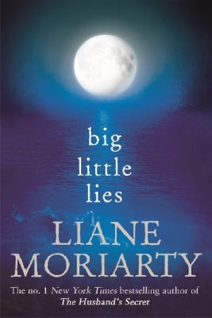
Big Little Lies by Liane Moriarty

Synopsis
Pirriwee Public is a beautiful little beachside primary school where children are taught that ‘sharing is caring.’ So how has the annual School Trivia Night ended in full-blown riot? Sirens are wailing. People are screaming. The principal is mortified.
And one parent is dead.
Was it a murder, a tragic accident or just good parents gone bad? As the parents at Pirriwee Public are about to discover, sometimes it’s the little lies that turn out to be the most lethal…

Discussion questions
- At the beginning of the novel, Madeline is enraged over Ziggy not being invited to Amabella’s birthday party. Why do you think Madeline becomes so angry about such a seemingly small injustice? Do you think Madeline is the kind of person who just looks for a fight, or do you think she was justified in feeling so upset?
- On the beach Jane’s mom shows that she has rather poor body image. Jane observes that women over 40 are constantly talking about their age. And Madeline says, “She didn’t want to admit, even to herself, just how much the ageing of her face really did genuinely depress her. She wanted to be above such superficial concerns. She wanted to be depressed about the state of the world….” [p. 82] Do you think this obsession with looks is specific to women, particularly women of a certain age?
- A lot of Madeline’s storyline is about the complications that arise from the merging of new modern families. What problems exist among families and extended families now that didn’t when you were a child?
- The power of secrets is a theme throughout the novel. Jane remembers, “She hadn’t told anyone. She’d swallowed it whole and pretended it meant nothing, and therefore it had come to mean everything.” [p. 220] Do you think this is a universal truth, that the more you keep something secret, the more power it takes on?
- At one point Jane thinks she and Ziggy will have to leave Pirriwee because “rich, beautiful people weren’t asked to leave anywhere.” [p. 362] Do you think different rules apply to rich people? Do you think being rich allowed Perry to get away with things longer than would have been likely if he hadn’t had money?
- At one point in the book, Susi says that, in Australia, one woman dies every week because of domestic violence. In the United States, more than three women are murdered by their husbands or boyfriends every day. Every nine seconds in the United States a woman is assaulted or beaten. Domestic violence is the leading cause of injury to women—more than that caused by car accidents, muggings, and rapes combined. Are you surprised by these statistics? Clearly, the author chose Celeste—the picture-perfect mom and/ wife as well as an educated lawyer—to be the victim of domestic violence in order to make a point. Do you think it’s plausible that someone like her would fall victim to abuse such as this?

Synopsis/Discussion questions from https://lianemoriarty.com.au/big-little-lies-readers-guide/

