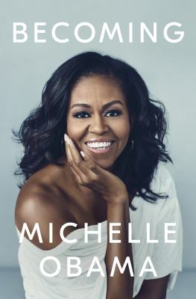
The Becoming by Michelle Obama

Synopsis
In her memoir, a work of deep reflection and mesmerizing storytelling, Michelle Obama invites readers into her world, chronicling the experiences that have shaped her -- from her childhood on the South Side of Chicago to her years as an executive balancing the demands of motherhood and work, to her time spent at the world's most famous address. With unerring honesty and lively wit, she describes her triumphs and her disappointments, both public and private, telling her full story as she has lived it -- in her own words and on her own terms.

Discussion questions
- Mrs. Obama begins her book with a story about making cheese toast on a quiet night at home, a few months after leaving the White House. Why do you think she chose this story to begin her memoir?
- In Becoming, we get to know the constellation of Mrs. Obama’s extended family through her eyes. Her grandfather, Southside, filled his house with music and makeshift speakers and merriment. Years later, Mrs. Obama would fill the White House with music and culture through live performances and several programs aimed at children. How do those kinds of early memories leave an imprint on us as we grow older? What were the sights and smells that you remember from visiting grandparents or other elders, and how have they left a mark on you?
- In discussing her neighborhood on the South Side of Chicago, Mrs. Obama writes, ‘Failure is a feeling long before it becomes an actual result. It’s vulnerability that breeds with self-doubt and then is escalated, often deliberately, by fear.’ How did this insight shape Mrs. Obama’s work and mission as First Lady? What can we all do – as individuals, parents, and community members – to help break this cycle?
- In discussing her neighborhood on the South Side of Chicago, Mrs. Obama writes, ‘Failure is a feeling long before it becomes an actual result. It’s vulnerability that breeds with self-doubt and then is escalated, often deliberately, by fear.’ How did this insight shape Mrs. Obama’s work and mission as First Lady? What can we all do – as individuals, parents, and community members – to help break this cycle?

- In Chapter 15, Mrs. Obama explains why she chose to support her husband’s run for the presidency despite her misgivings about politics. What made her change her mind? Would you have made the same choice? How do you balance the competing worlds of family life and work in your life?
- In the epilogue, Mrs. Obama writes, ‘I’ve never been a fan of politics, and my experience over the last ten years has done little to change that.’ Did you find her statement surprising? Do you think politics is an effective way to make social change?
- Why do you think Michelle Obama chose to name her memoir Becoming? What does the idea of ‘becoming’ mean to you?

Synopsis/Discussion questions from https://www.penguinrandomhouse.com/books/562881/becoming-by-michelle-obama/9781524763145/readers-guide/

