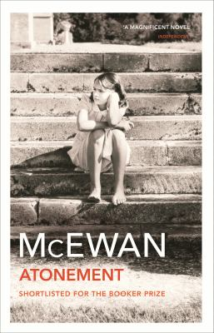
Atonement by Ian McEwan

Synopsis
Briony Tallis is a literary, self-important 13-year-old who lives in an English country estate in 1935. From a window of the estate, Briony witnesses her older sister Cecilia and the Tallises’ gardener, Robbie Turner accidentally break a family heirloom vase in front of a fountain. When Cecilia removes her clothes in front of Robbie to retrieve the shards from the fountain, Briony starts to think Robbie is a threat to her sister. Later, Briony finds Lola being raped in a remote part of the estate. The assailant runs away before Briony can identify him, but she convinces both Lola and herself that she saw Robbie commit the crime. Robbie returns to the house and he is taken into police custody.
Part Two resumes after Robbie has served three and a half years in prison for Lola’s assault. During that time, he has been in constant correspondence with Cecilia who has cut ties with her family and started a career as a nurse. Cecilia’s latest letter informs Robbie that Briony has contacted her in the hopes of retracting the false testimony she made years earlier. The outbreak of World War II allows Robbie to end his sentence by enlisting in the army. He goes to fight in France.
Part Three focuses on Briony, who has foregone college to work as a nurse during the war. The harrowing experience of treating an influx of injured men causes Briony to mature. She returns home for a wedding and, afterwards, pays a visit to Cecilia and Robbie. The atmosphere is tense, but Briony agrees to take the steps necessary to alert the relevant legal authorities of her change in testimony. Briony understands that after she finishes the tasks she agreed to, she must begin an in-depth process of “atonement.”

Discussion questions
- A passion for order, a lively imagination, and a desire for attention seem to be Briony's strongest traits. In what ways is she still a child? Why does the scene she witnesses at the fountain change her whole perspective on writing?
- What happens between Robbie and Cecilia at the fountain? What symbolic role does Uncle Clem's precious vase play in the novel? Is it significant that the vase is glued together by Cecilia, and broken finally during the war by Betty as she readies the house to accept evacuees?
- The scene in the library is one of the most provocative and moving descriptions of sex in recent fiction. How does the fact that it is narrated from Robbie's point of view affect how the reader feels about what happens to him shortly afterwards? Is it understandable that Briony, looking on, perceives this act of love as an act of violence?
- Lola has a critical role in the story's plot. Why does she tell Briony that her brothers caused the marks on her wrists and arms? Why does she allow Briony to take over her story when she is attacked later in the evening?
- McEwan's Atonement has two endings—one in which the fantasy of love is fulfilled, and one in which that fantasy is stripped away. What is the emotional effect of this double ending?
- Is Briony's novel effective, in her own conscience, as an act of atonement? Does the completed novel compel the reader to forgive her?
Discussion questions from https://www.readinggroupguides.com/reviews/atonement/guide

