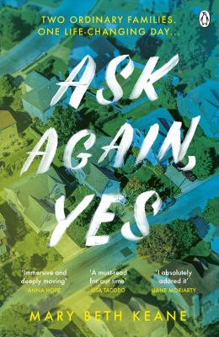
Ask Again, Yes by Mary Beth Keane

Synopsis
Gillam, upstate New York: a town of ordinary, big-lawned suburban houses. The Gleesons have recently moved there and soon welcome the Stanhopes as their new neighbours. Lonely Lena Gleeson wants a friend but Anne Stanhope - cold, elegant, unstable - wants to be left alone.
When a terrible tragedy engulfs them all, the families are divided, seemingly for good. Until their children, Kate and Peter, meet again as adults, and the violence of the past must be vanquished by the power of love.

Discussion questions
- Ask Again, Yes grapples with the idea of learning from the past. What lessons do Kate and Peter learn from their parents’ experiences? What mistakes do they repeat?
- Do Francis Gleeson and Anne Stanhope – both Irish immigrants – experience things differently from their American-born spouses? Do you think this contributes to tensions within the couples, and between the two families?
- Ask Again, Yes is set over the course of four decades. How do attitudes toward mental health and addiction change over that time? How do these changes affect the characters? For example, how do Brian and George Stanhope differ in their attitudes toward drinking?
- Francis marvels at how many pieces had to come together for a woman like Lena to exist and for him to have met her. What role do you think fate plays in this novel? Do the characters have free will to make their own choices? Why or why not?
- When Kate learns about the episode at Food King, she momentarily thinks that it couldn’t have been as dramatic as Peter was making it out to be. Then she realizes that it was, in fact, the opposite, ‘that it was such a big deal that the adults had been careful not to talk about it in front of the kids’. What role does keeping secrets – from children, parents, partners – play throughout the novel? Do you think certain events could have been avoided if the characters had been more open with each other?
- The idea of inherited traits and characteristics appears frequently in the novel. Trauma is another thing that is passed down from generation to generation. Do Kate and Peter address the legacy of trauma they’ve inherited from their parents?
- The novel is divided into four parts. Discuss the significance of each of the part titles—‘Gillam,’ ‘Queens,’ ‘Two by Two,’ and ‘Muster.’ Why do you think Mary Beth Keane chose to structure the story this way?
- At the end of the book, Francis thinks, ‘It was always the same. People didn’t change’. Do you think he really believes this?
Synopsis/Discussion questions from https://www.penguin.com.au/book-clubs/2403-ask-again-yes-book-club-notes

