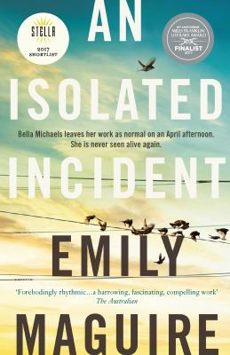
An Isolated incident by Emily Maguire

Synopsis
The story begins with Chris, a local barmaid and occasional sex-worker, finding out that her beloved little sister has been found dead. From here, we follow Chris as she freefalls through her grief and struggles to fathom the unfathomable. We learn how easy it is to romanticise the dead, and how fierce we can be when it comes to protecting those we love. We understand how women can simultaneously fear and adore the opposite sex; condemning behaviour in one man and excusing it in another.
Chris also shows us how we internalise the stories we hear about ourselves. When May Norman is first introduced, it is through the byline of an article that she has written and published with AustraliaToday.com – a fictional online news outlet. These articles, documenting the case and community reaction to Bella’s death, continue to appear throughout the novel. But we also get to know May as a character in her own dedicated chapters. While Chris hides from the media to process her guilt and grief, May develops a compulsion to research and report the crime long after the news cycle has moved on.
Through May we gain insight into the struggle to maintain journalistic integrity when editors and audiences demand more and more details, faster and faster. We also understand how profoundly we are shaken by seemingly random crimes that ‘could happen to anyone’ – how they both captivate and repel us, and how we try desperately to make sense of them as a form of self-preservation.

Discussion questions
- Small towns are notorious for their overactive “rumour mills”, but are also considerably insular and private. How do you think community response to senseless crime or tragedy differs in a small town compared to a large city?
- The insidiousness of domestic violence is threaded throughout this novel. Chris, in particular, has been the victim of domestic violence at the hands of a number of perpetrators throughout her life. How do you think this shapes her understanding of and relationship with men?
- Chris is sceptical and suspicious of the media. Where do you draw the line between freedom of information and personal privacy? Between newsworthiness and sensationalism?
- The correlation between alcoholism and a range of anti-social behaviour is addressed a number of times in An Isolated Incident. In Australia, politicians and media personalities frequently blame ‘alcohol-fuelled violence’ for late night fights, physical and sexual attacks and ‘coward punches’. To what extent do you feel alcohol (or other substances) can or should be blamed for the behaviour of those under its influence?
- In what ways does An Isolated Incident change or challenge your perception of sex workers?
- As Chris spirals to the depths of her despair, she begins to see and hear Bella around her home. Do you think these are hallucinations or visits by a ghost? Or perhaps something in between?
Synopsis/Discussion questions from https://www.panmacmillan.com.au/9781760553562/

