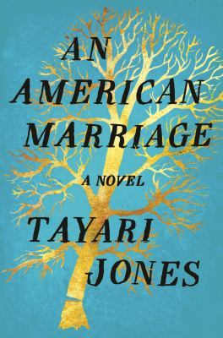
An American Marriage by Tayari Jones

Synopsis
Newlyweds, Celestial and Roy, are the embodiment of both the American Dream and the New South. He is a young executive and she is an artist on the brink of an exciting career. They are settling into the routine of their life together, when they are ripped apart by circumstances neither could have imagined. Roy is arrested and sentenced to twelve years for a crime Celestial knows he didn’t commit.
Though fiercely independent, Celestial finds herself bereft and unmoored, taking comfort in Andre, her childhood friend, and best man at their wedding. As Roy’s time in prison passes, she is unable to hold on to the love that has been her center. After five years, Roy’s conviction is suddenly overturned, and he returns to Atlanta ready to resume their life together.

Discussion questions
- When Celestial asks Roy if he would have waited for her for more than five years, he doesn’t answer her question but reminds her that, as a woman, she would not have been imprisoned in the first place. Do you feel that his response is valid, and do you think it justifies his infidelity?
- In her “Dear John” letter to Roy, Celestial says, “I will continue to support you, but not as your wife.” What do you think she means by this statement? Do you feel that Roy is wrong to reject her offer?
- You may not have noticed that Tayari Jones does not specify the race of the woman who accuses Roy of rape. How did you picture this woman? What difference does the race of this woman make in the way you understand the novel’s storyline?
- Andre insists that he doesn’t owe Roy an apology for the way his relationship with Celestial changed. Do you agree? Why or why not?
- Big Roy explains that he and Olive never had children of their own because Olive feared that he would not love Roy as much if he had his “own” children. Do you feel she had the authority to make that decision? And do you feel she was right in making that decision?
- When Roy is released from prison, he first goes to his childhood home and almost immediately makes a connection with Davina. Do you feel that given the tenuous relationship he has with Celestial—who is still legally his wife—he is cheating? Why or why not?
- It is obvious that Andre is different from Roy in many ways. Do you feel that ultimately he is a better match for Celestial? If so, why? Also, why do you think Celestial and Andre decide against formally marrying? Do you think that as a couple they will be good and nurturing parents? Do you feel that as a couple, they will be better at parenting than Celestial and Roy would have been? If so, why?
- Toward the end of the novel, Celestial does a complete about-face and returns to Roy. What do you think her emotions were in coming to that decision? Do you feel that it was the right decision?
Discussion questions from https://www.oprah.com/oprahsbookclub/an-american-marriage-by-tayari-jones-reading-guide

