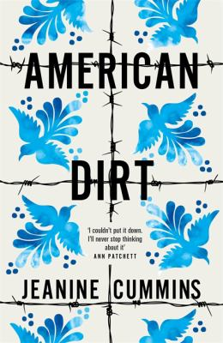
American Dirt by Jeanine Cummins

Synopsis
Lydia Quixano Pérez lives in the Mexican city of Acapulco. She runs a bookstore. She has a son, Luca, the love of her life, and a wonderful husband who is a journalist. And while there are cracks beginning to show in Acapulco because of the drug cartels, her life is, by and large, fairly comfortable.
Even though she knows they’ll never sell, Lydia stocks some of her all-time favorite books in her store. And then one day a man enters the shop to browse and comes up to the register with a few books he would like to buy—two of them her favorites. Javier is erudite. He is charming. And, unbeknownst to Lydia, he is the jefe of the newest drug cartel that has gruesomely taken over the city. When Lydia’s husband’s tell-all profile of Javier is published, none of their lives will ever be the same.
Forced to flee, Lydia and eight-year-old Luca soon find themselves miles and worlds away from their comfortable middle-class existence. Instantly transformed into migrants, Lydia and Luca ride la bestia—trains that make their way north toward the United States, which is the only place Javier’s reach doesn’t extend. As they join the countless people trying to reach el norte, Lydia soon sees that everyone is running from something. But what exactly are they running to?

Discussion questions
- Were you aware of the controversy surrounding American Dirt prior to reading it? If yes, did it impact the story for you in any way?
- Should Sebastian have written the article on Javier Crespo? Why or why not?
- We learn that Lydia owns a bookstore in Acapulco and she becomes friends with a charming man named Javier who we learn is actually the head of a cartel. What did you think about this storyline of them becoming friends? Did Javier actually fall in love with Lydia? Why do you think the author thought it was important for Lydia to have a personal connection with the cartel leader that will eventually kill her family?
- What did you think about the descriptions of Acapulco?
- What would you have done if you were Lydia?
- This horrifying journey is non-stop and the violence is told in extreme detail with some even calling the story “torture porn.” What are you thoughts on this? Do you think the descriptions were too much or did it fit with the story?
- In the end, Lydia, Luca, Rebeca and Soledad make it to the U.S. What did you think about the ending? How do you think life will be like for them in the U.S.?

Synopsis/Discussion questions from https://bookclubchat.com/books/book-club-questions-for-american-dirt-by-jeanine-cummins/

