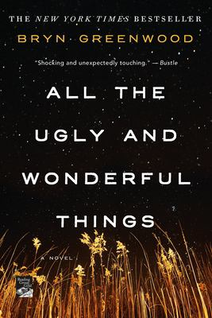
All the Ugly and Wonderful Things by Bryn Greenwood

Synopsis
As the daughter of a drug dealer, Wavy knows not to trust people, not even her own parents. It's safer to keep her mouth shut and stay out of sight. Struggling to raise her little brother, Donal, eight-year-old Wavy is the only responsible adult around. Obsessed with the constellations, she finds peace in the starry night sky above the fields behind her house, until one night her star gazing causes an accident. After witnessing his motorcycle wreck, she forms an unusual friendship with one of her father's thugs, Kellen, a tattooed ex-con with a heart of gold.
By the time Wavy is a teenager, her relationship with Kellen is the only tender thing in a brutal world of addicts and debauchery. When tragedy rips Wavy's family apart, a well-meaning aunt steps in, and what is beautiful to Wavy looks ugly under the scrutiny of the outside world.

Discussion questions
- From the first moment we meet Wavy, her life is filled with rules. Most are her mother’s rules, but some are hers. What rules are holding Wavy back and which ones does she use to construct a sense of safety? How do the rules change as she grows up?
- Kellen is a murderer and Wavy knows this from an early point in her relationship with him. How is she able to know this while still considering him a good person? What things in her life have prepared her to accept two seemingly contradictory ideas? How do you feel about this paradox?
- Aunt Brenda’s perspective is the one that most clearly correlates to our current social attitudes toward relationships like Wavy and Kellen’s, but is she the hero of this story? To what degree do you sympathize with her?
- Compared to Wavy, her cousins and her college roommate are ostensibly the product of “normal” upbringings. In what ways are they more emotionally healthy than Wavy? In what ways do they have similar emotional issues?
- As much as we may wish for Wavy and Kellen’s relationship to remain platonic, what do you feel contributes to its steady shift toward becoming first romantic and then sexual? What might have happened if it had remained platonic?
- Amy narrates a large portion of Wavy’s life, while only revealing parts of her own. How does she choose what to reveal? And why might she prefer to tell Wavy’s story over her own?
- What is the dynamic between Wavy and Kellen as husband and wife at the end? Who do you see as the decision maker? The moral compass? What other roles have they taken on, and how comfortable are they in those roles? Considering their backgrounds, how likely are they to succeed in creating a healthy relationship and a “normal” family?
Synopsis/Discussion questions from https://us.macmillan.com/books/9781250153968/alltheuglyandwonderfulthings

