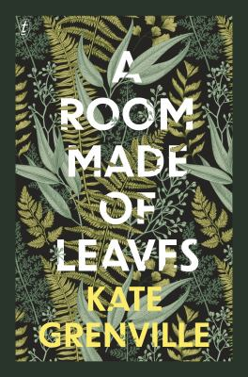
A Room made of leaves by Kate Grenville

Synopsis
What if Elizabeth Macarthur’s letters and journals were a mask hiding her true experiences and emotions? What if the contemporary expectations of a gentlewoman prevented her from writing her truth to anyone but herself? This is Kate Grenville’s starting point for this brilliant novel, a starting point encouraged by Elizabeth Macarthur’s recommendation not to believe too quickly.
A Room Made of Leaves, Kate Grenville tells us at the end, is neither history nor pure invention. It is a reminder to question received truths about history, most especially about women and First Nations people. Perhaps Elizabeth thinks, what she thought of as trade was actually a lesson from the Burramattagal in how to do things properly, and how to act with grace, forgiveness and generosity.
A Room Made of Leaves is an absorbing narrative of a woman’s changing self, of ambition and destiny, of learning and doing and being. It is about how a self can shift and change through life, how it is bound and freed through life’s stages. Indeed the novel is so absorbing and feels so real, that it is easy to forget not to believe. It feels entirely believable.

Discussion questions
- A Room Made of Leaves is dedicated to ‘all those whose stories have been silenced.’ Are those voices being heard more now? If so, how are they being heard?
- At the end of her ‘memoir’, Elizabeth reflects that behind the dispossession, cruelties, and murders of the Gadigal, Wangal, Cameraygal and Burramattagal is ‘another fundamental violence: the replacement of the true history by a false one’. Does this violence continue today? Or are we closer to a truer history?
- Elizabeth has two rooms made of leaves in the novel: the one she shares with Mr Dawes and her private one by the river on the Macarthurs’ sheep farm. How are the two rooms similar and different? How do they each contribute to her story?
- How does Elizabeth’s dissembling through her life tie in with the novel’s themes of fact and fiction? Does she dissemble to be truer to herself? How free is she in her choices about whether to be true to herself or not? Is Elizabeth wrong when she feels that she has power and that allowing Mr Macarthur to ‘assail’ her is her decision? Why doesn’t she feel the ‘lie’ in the event as it happens?
- Elizabeth gradually comes to acknowledge the beauty of the foreign landscape she finds herself in. By the end of the novel, she feels a deep connection with the country and that she belongs, that it is her home. How do non-Indigenous people make a connection with the land? How does it compare with the connection First Nations people have with country?
- Elizabeth recognises her lack of courage in not being willing to sit with Daringa and the other Gadigal women she knows in town. She also realises that the settlers’ ‘ownership’ of the land is theft. She feels ‘a shadow at the edge of my life, the consciousness that I was on land that other people knew was theirs’. Are she and Dawes the only ones conscious of this shadow in A Room Made of Leaves? Are non-Indigenous Australians today conscious of this shadow?

Synopsis/Discussion questions from https://www.textpublishing.com.au/books/a-room-made-of-leaves

