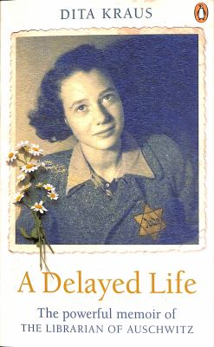
A Delayed Life by Dita Kraus

Synopsis
A Delayed Life is the breathtaking memoir that tells the story of Dita Kraus, the real-life Librarian of Auschwitz.
Dita Kraus grew up in Prague in an intellectual, middle-class Jewish family. She went to school, played with her friends, and never thought of herself as being different—until the advent of the Holocaust. Torn from her home, Dita was sent to Auschwitz with her family.
From her time in the children’s block of Auschwitz to her liberation from the camps and on into her adulthood, Dita’s powerful memoir sheds light on an incredible life—one that is delayed no longer.

Discussion questions
- Why do you think the author divides her memoir into three parts? Why is it important to hear about Dita’s life before and after the Holocaust?
- Discuss the title of the book. Do you agree with Dita that she had been living a delayed life? If so, at what point do you think she stopped delaying?
- Dita mentions that she came across the word “Jew” for the first time when she was in grade three. What is Dita’s relationship with her Jewish identity? How does it change throughout her life?
- In the events leading up to the Holocaust, Dita recalls the moments when she was suddenly no longer allowed to go to school or go to the theater. Were you surprised by how she described her first experiences of anti-Semitism? How were these events seen differently from the eyes of a young girl?
- As the librarian of Auschwitz, Dita watched over the twelve books they had in the camp. Why do you think it was so important for her and the other survivors to continue appreciating art and education? Can you identify some moments when art helped Dita through her hardship?
- When Dita worked as an interpreter during the Liberation, she interrogated Bubi, a former SS officer. Discuss the conflicted feelings she felt at that moment. Why do you think Dita handed Bubi cigarettes?
- When talking about the uncovered pictures painted by the children in Terezín, Dita wanted to make it clear that the drawings were not acts of heroism, and they were kids just being kids. Why do you think it was important for Dita to clarify this?
- While watching a documentary on Bergen-Belsen, Dita was so excited when she spotted herself on film. She says, “And now there was proof that it happened, that I had really been there.” Why do you think Dita would rather remember than forget what she had gone through?
Synopsis/Discussion questions from https://us.macmillan.com/books/9781250821270/adelayedlife

