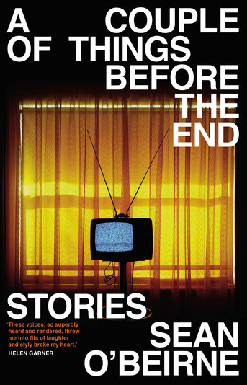
A Couple of Things Before the End by Sean O’Beirne

Synopsis
A woman on a passenger ship in 1958 gets involved with a young, wild Barry Humphries. A man looks back to the 1970s and his time as a member of Australia’s least competent scout troop. In 1988, a teenage boy recalls his sexual initiation, out on the tanbark. In 2015, two sisters text in Kmart about how to manage their irascible, isolated mum.
Then, in the near future, a racist demagogue addresses the press the day after his electoral triumph. As the cities heat up and lose their water, a lady from one of the ‘better suburbs’ makes every effort to get her family into an exclusive gated community.

Discussion questions
- While each story in the book is self-contained, a pattern emerges so that by the book’s conclusion we have been shown Australia’s past, present and possible future. How did your experience of the book change as it moved from light-hearted nostalgia to something more sinister?
- How does O’Beirne use voice in the book? Many of the stories present one side of a conversation and we, the reader, must fill the gaps. Why do you think he did this? How easy was it to fill the gaps?
- The book paints a vivid portrait of suburban white Australia, particularly in the 1970s and 1980s. As we progress through the stories from the past to the future, how does that portrait change?
- Nostalgia is a strong theme in the book, both for the characters – from a man remembering his time as a scout to Jack’s ‘memoirs of a life’ – and for the reader. What elements of the book did you relate to in your own life? In which characters did you see yourself, or someone else?
- Discuss the characters in each story. Can you think of people in real life to whom they might be a satirical nod? • What does the book say about class, capitalism, structures of power, and the media?
- Masculinity is a common theme in the book. Discuss how it is expressed, and the specific Australian masculinity that is presented throughout the book, particularly in stories like ‘A Night with the Fellas’ and ‘The Anzac Spirit’.
- Discuss the book title, A Couple of Things Before the End, and your interpretation of its meaning.
- In the story ‘Scout’, is the narrator negative about his childhood experience, or positive?
- In the author’s portrait of Australia, as presented in the book, who is seen and who is unseen?
- The final story, ‘Bunker’, is open-ended. Where do you think the story might have gone from there?

Discussion questions from https://www.blackincbooks.com.au/books/couple-things-end

