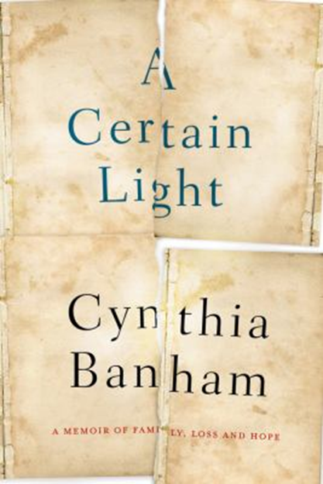
A Certain Light: a memoir of family, loss and hope by Cynthia Banham

Synopsis
'Life is not defined by the bad things that happen to us. It certainly isn't for me.'
Written for her young son so that he would know what had happened to his mother, Cynthia Banham's inspiring family memoir uncovers a true picture of what survival means:
'This book tells a story that I tried to write many times before, but couldn't. For a long time, it was too painful to tell. It is also one I hadn't known how to tell. It had to be more than a story about surviving a plane crash, a random event without intrinsic meaning.'
Unable till now to write her own story, Cynthia found that the lives of her Italian grandfather, Alfredo, and his intriguing older sister, Amelia, resonated with her own. Discovering their sacrifice, joy, fear and love, from Trieste to Germany and America, and finally to Australia, their stories mirror and illuminate Cynthia's own determination and courage in the face of overwhelming adversity.
From a remarkable writer, and told with unflinching honesty and compassion, A Certain Light speaks to the heart of what really matters in life.

Discussion questions

None found on line or by publisher at this stage.

Ideas –
- The blending of the two stories – Cynthia’s accident and life w a disability AND her grandfather’s survival of incarceration in WW2. How well does it work?
- Cs depiction of her mother – something about that relationship and Cs acceptance of her mother’s world view??

